An Explanation-Consistency Framework for Trustworthy Network Intrusion Detection: Embedding a Glass-Box Model Inside a Heterogeneous Stacked Ensemble
Khandaker Saifuzzaman
School of Physics, Engineering and Computer Science, University of Hertfordshire, Hatfield, United Kingdom
Corresponding author: Khandaker Saifuzzaman (kh.saif17@gmail.com)
ORCID: 0000-0001-6456-3652

Abstract
Security operations centres increasingly receive not only alerts from machine-learning intrusion detection systems but explanations for them, produced by post-hoc methods such as SHAP. These attributions are approximations, and in deployed systems they are rarely checked against any reference that is exact by construction; an unverified explanation can misdirect triage as easily as a missed detection. This paper presents an explanation-consistency framework that makes such checking a property of the deployed detector itself. The enabling engineering decision is to embed a glass-box model, the Explainable Boosting Machine (EBM), as a base learner inside a heterogeneous stacked ensemble alongside CatBoost and ExtraTrees: three learning paradigms whose diversity restores genuine ensemble gains, where a homogeneous soft-voted XGBoost, LightGBM, and Random Forest ensemble fails to beat standalone LightGBM. Because EBM’s attributions are exact, the detector carries its own reference for auditing the SHAP explanations delivered to analysts, at no additional inference cost. Under a leak-controlled pipeline with capped in-fold SMOTE, per-fold calibration, and a 25-feature ablation-selected subset, the stacked ensemble reaches 99.83% accuracy and 0.9984 weighted F1 on CICIDS-2017, exceeding its best base member (McNemar p = 2.5×10⁻⁴) and a LightGBM reference (28.1% relative error reduction). SHAP and exact EBM attributions agree on feature identity (top-10 agreement 0.9; Spearman ρ = 0.775), though only moderately on rank order. Leak-free per-class threshold calibration cuts XSS false alarms by 29%. Parallel inference runs at 4.33 μs per sample. The findings replicate under native retraining on UNSW-NB15 (ρ = 0.840; Analysis false alarms cut 83%).

Keywords: Network Intrusion Detection, Explainable AI, Explanation Consistency, Explainable Boosting Machine, Stacked Generalisation, Security Operations, Threshold Calibration.

1. Introduction
As network infrastructures evolve toward Industry 5.0 and the Internet of Things, the attack surface available to malicious actors continues to expand. Signature-based intrusion detection is increasingly inadequate against attacks (distributed denial-of-service campaigns, brute-force credential attacks, and encrypted web exploits) that are progressively harder to distinguish from benign traffic, and machine learning has become the primary defensive mechanism. In operational deployments the model’s output is consumed twice over: a security operations centre (SOC) acts on the alert, and increasingly also on an explanation of the alert, which steers triage, escalation, and response. Two structural weaknesses persist across the academic literature, and both surface at exactly this operational boundary.
- Unchecked explanations. Post-hoc explainers such as SHAP are now routinely attached to NIDS, but their attributions are approximations, and recent surveys note that almost no NIDS work attempts any consistency check on them [52,58]. When two post-hoc explainers agree, both may share the same approximation biases; what is missing is a reference that is exact by construction, available inside the deployed system where the explanations are produced.
- Illusory ensemble gains. The dominant recipe of combining several gradient-boosted tree models by voting quietly assumes the members make different errors. They often do not: XGBoost and LightGBM are near-identical leaf-wise boosters, and we show in Section 4.1 that a soft-voted XGBoost+LightGBM+Random-Forest ensemble fails to outperform standalone LightGBM on CICIDS-2017. Many published ensemble improvements may rest on weak baselines rather than genuine combination gains.
This paper addresses both weaknesses with one engineering decision: build the ensemble from three different learning paradigms: ordered boosting on symmetric trees (CatBoost), extremely randomised bagging (ExtraTrees), and a cyclic-boosted additive glass-box model (the Explainable Boosting Machine, EBM), combined by stacked generalisation. The glass-box member, whose feature attributions are exact by construction, turns the deployed detector into its own explanation-auditing instrument: the exact reference that post-hoc explanations lack ships inside the system and costs nothing extra at inference. Diversity, in turn, restores genuine ensemble gains. We frame the result deliberately as engineering for trustworthy operational deployment rather than as a new learning algorithm: every component is an established method, and the contribution lies in how the components are combined, evaluated under a leak-controlled and fully paired protocol, and exposed to the operators who must act on their output.
Contributions. (i) An explanation-consistency framework for deployed NIDS: to our knowledge the first glass-box-versus-post-hoc consistency study in this field, using formal agreement metrics from the disagreement-problem literature under a same-sample, same-semantics protocol (Sections 3.6 and 4.5); (ii) the engineering contribution that enables it: a NIDS architecture embedding a glass-box model (EBM) as a base learner inside a heterogeneous stacked ensemble, making the exact attribution reference a deployed, load-bearing component rather than an offline artefact (Section 3.4); (iii) an empirical demonstration that a homogeneous boosted voting ensemble fails to beat its best member on CICIDS-2017, and that paradigm diversity combined by stacking restores genuine ensemble gains (Sections 3.4.1 and 4.1); (iv) an operational deployment layer: SOC-aware per-class threshold calibration tuned leak-free on real-prevalence data, giving operators explicit, inspectable control of the false-alarm rate, at microsecond-scale parallel inference (Sections 3.5, 4.4, and 4.6); (v) a feature-space finding that inter-arrival-time statistics substantially improve web-attack detection (XSS F1: 0.09 → 0.42 from feature selection alone); and (vi) an evaluation protocol in which every model comparison shares identical folds and base fits, making all McNemar tests properly paired; this design lets the above contributions rest on statistically valid, reproducible evidence.

2. Related Work
Ensemble learning in NIDS. Ensemble methods consistently outperform single classical models on flow-based benchmarks, as surveyed by Ahmad et al. [1] across both classical and deep learning approaches. Deep learning methods such as recurrent neural networks [41] and ensembles of autoencoders [29] have demonstrated strong detection rates but offer limited interpretability. Fitni and Ramli [16] improved detection with a majority-voting ensemble of heterogeneous classifiers and highlighted the data-leakage risk of resampling before cross-validation. The computational load of high-dimensional traffic is addressed by hybrid feature selection, as shown by Al-Omari and Al-Haija [2] and Arreche et al. [5], who combined boosting with bagging in a two-level framework. The boosted-tree learners that dominate this literature share a common lineage in gradient boosting [17] and its scalable modern implementations, XGBoost [11] and LightGBM [23], alongside the bagging-based Random Forest [8] and its extremely randomised variant [18]. CatBoost [34] adds ordered boosting on symmetric trees, a structurally distinct scheme we exploit for diversity. Stacked generalisation [40] appears in recent NIDS work, but its base learners are almost always drawn from the same family of gradient-boosted trees, leaving error correlation (the property that determines whether an ensemble can outperform its members) unexamined, despite classical ensemble theory tying combination gains directly to member error diversity [44,45].
Class imbalance in intrusion detection. NIDS datasets are severely skewed toward benign traffic, and the treatment of imbalance materially affects minority-attack detection. Synthetic oversampling (SMOTE [10]) and its adaptive variant (ADASYN [21]) are the field's default remedies, surveyed comprehensively by He and Garcia [22]. Buda et al. [9] showed across deep and classical models that oversampling and decision-threshold adjustment are the most reliable interventions, while the cost-sensitive perspective [15] reframes the problem at the decision layer rather than the data layer. We adopt both views: leak-proof capped oversampling during training and per-class threshold calibration at inference, the latter tuned on real-prevalence data to avoid the distortion that resampling introduces into probability estimates.
Glass-box models. The Explainable Boosting Machine [26,32,46] is a cyclic-boosted generalised additive model whose prediction is a sum of per-feature shape functions, so its global and local attributions are exact rather than approximated, a property that has motivated its deployment in other high-stakes domains [47]. The case for using inherently interpretable models rather than attaching post-hoc explanations to black boxes has been argued forcefully by Rudin [37]. EBM has appeared in intrusion detection only as a standalone classifier; to our knowledge no prior NIDS work deploys it as a base learner inside a heterogeneous ensemble, where its exactness can be exploited at no extra cost.
Explainability and the disagreement problem. SHAP [27] dominates NIDS explainability [6,20,39], but its attributions are post-hoc approximations. Krishna et al. [24] formalised the disagreement problem: different explainers routinely disagree, and proposed agreement metrics (top-k feature, rank, and sign agreement) that we adopt. End-to-end XAI-IDS frameworks [6] benchmark multiple post-hoc explainers, and recent work identifies cross-explanation consistency checking as an open gap, noting that the rare existing consistency checks compare two post-hoc methods (SHAP vs LIME [36]), whose mutual agreement cannot rule out a shared approximation artefact. Comparing a post-hoc explainer against an exact glass-box member of the same deployed ensemble, as done here, removes the approximation uncertainty from one side of the comparison; it cannot, however, exclude data-level artefacts that shape both models (Section 4.5).
Benchmarks and cross-dataset generalisation. Detection results are benchmark-sensitive. CICIDS-2017 [38], generated with CICFlowMeter [14], remains the most-used flow benchmark, though documented labelling imperfections in it counsel caution when interpreting per-class results [42], while UNSW-NB15 [30], built with a different Argus/Bro toolchain, and the recent CIC-IoT-2023 [31] provide complementary distributions. Because feature sets differ across extractors, models rarely transfer zero-shot [49], and single-benchmark evaluations risk reporting extractor-specific artefacts; native multi-dataset validation, adopted here, is the more credible test of generalisation. Federated and IoT-oriented deployments [35,39] further motivate detectors that are both accurate and interpretable on heterogeneous traffic.

2.1. Recent Explainable IDS Work (2024–2026)
Explainability has moved to the centre of the NIDS literature in the last three years, and the pattern across recent systems sharpens the gap this paper addresses. Wang et al. [50] established the dominant template: a black-box detector with SHAP attached, explanation quality argued by plausibility. Recent work refines that template without changing its trust structure. Wali et al. [54] pair a Random Forest detector with post-hoc attributions used to flag unreliable inputs under adversarial conditions; AL-Nomasy et al. [55] distil a transformer teacher into a lightweight student for IoT deployment and attach an explainability layer for analyst transparency; Gao et al. [56] apply causal feature selection and explanation-guided model optimisation, so explanations steer training rather than being audited at inference; and Cerasuolo et al. [57] bring explainability to incremental model updates on IoT traffic. In each case the explanation delivered to the operator remains a single post-hoc approximation whose fidelity is asserted rather than measured.
Evaluation-oriented work goes one step further. Arreche et al. [53] benchmark SHAP and LIME for network intrusion detection across six criteria (descriptive accuracy, sparsity, stability, efficiency, robustness, and completeness), and Warnecke et al. [51] evaluate explanation methods for security applications under fidelity and robustness criteria. In both, however, the reference for judging an explanation is either the black box’s behaviour under perturbation or another approximate explainer; no attribution that is exact by construction is available anywhere in the pipeline. Surveys of explainable intrusion detection [52,58] accordingly list validation of explanations among the field’s open problems: analysts are asked to act on attributions that nothing in the deployed system can corroborate. Table B situates the present work in this landscape. To our knowledge, no prior NIDS embeds an exact glass-box reference inside the deployed detector and audits the post-hoc explanations it serves against that reference with formal agreement metrics.

Work | Detector | Explanations | Explanation check | Focus
Wang et al. 2020 [50] | Single black-box classifier | SHAP (post-hoc) | None | Analyst insight
Warnecke et al. 2020 [51] | Deep models (security tasks) | Gradient and perturbation methods (post-hoc) | Fidelity and robustness criteria; no exact reference | Explainer evaluation
Arreche et al. 2024 [53] | Seven black-box models | SHAP and LIME (post-hoc) | Six perturbation-based criteria; explainer vs explainer | Explainer benchmarking
Wali et al. 2025 [54] | Random Forest | Post-hoc attributions | Explanations flag adversarial inputs; explainer itself unchecked | Adversarial reliability
AL-Nomasy et al. 2025 [55] | Knowledge-distilled transformer | Explainability layer (post-hoc) | None | Lightweight IoT deployment
Gao et al. 2025 [56] | Detector with causal feature selection | Explanation-guided optimisation | Explanations steer training; not audited at inference | Robust detection
Cerasuolo et al. 2025 [57] | Incremental deep models | Post-hoc attributions | None | IoT model updates
This work | Heterogeneous stack (CatBoost, ExtraTrees, EBM) | SHAP (post-hoc) and exact EBM terms | Post-hoc audited against embedded exact reference with formal agreement metrics | SOC deployment: consistency, thresholds, latency
Table B. Positioning against recent explainable NIDS work. Post-hoc attributions are approximations computed on a trained model; exact attributions follow analytically from the model structure (Eq. 5).

2.2. Gap Analysis
To the best of our knowledge, no prior NIDS work (a) embeds an exact glass-box model as a stacked base learner, (b) checks post-hoc SHAP attributions for consistency against exact attributions from inside the deployed ensemble using formal agreement metrics, or (c) couples this with leak-proof resampling, real-prevalence threshold calibration, and fully paired statistical testing on a shared-fold harness. The recent systems surveyed in Section 2.1 sharpen rather than close these gaps: explanations are attached, benchmarked against one another, or used to guide training, but the deployed detector never carries a reference that is exact by construction. This work addresses all three gaps simultaneously, and frames the result as an operational trust property of the deployed system rather than as a new learning algorithm.

3. Methodology

3.1. Dataset and Preprocessing
Experiments use CICIDS-2017 [38]: 2,827,876 flows after removing infinite values and NaNs, with 78 CICFlowMeter [14] features. Label strings were repaired at load time (the dataset's cp1252 en-dash decodes to U+FFFD under UTF-8, corrupting the two web-attack class names) and whitespace normalised. Numerical features were standardised; the label was integer-encoded. For computational tractability all experiments use a 20% stratified sample (565,563 flows); classes with fewer than 15 post-sampling instances (Heartbleed, Infiltration, SQL Injection) were removed, leaving 12 classes, and labels were re-encoded to consecutive integers. The sampling fraction is a disclosed design parameter.
A network flow F aggregates the packets that share a common key within a time window, where the flow key is the 5-tuple:
$F = \left\{SrcIP, DstIP, SrcPort, DstPort, Protocol\right\}$ (1)

3.2. Leak-Proof Capped Class-Imbalance Resolution
CICIDS-2017 is severely imbalanced (454,265 BENIGN vs 130 XSS flows in our sample). SMOTE [10] generates a synthetic minority point on the segment joining a sample and one of its k nearest minority neighbours:
$x_{new} = x_{i} + λ\left(x_{z_{i}} - x_{i}\right), λ ∈ \left[0, 1\right]$ (2)
Two safeguards differentiate this pipeline from common practice. First, SMOTE is applied strictly inside each training fold, so synthetic points never contaminate validation or test data. Second, oversampling is capped: each minority class is lifted to at most 50,000 samples rather than to the majority count, preventing the resampled training set from inflating to tens of millions of rows while preserving minority signal; k is auto-tuned to the rarest class's fold size. ADASYN [21] is evaluated as an alternative in Section 4.4.

3.3. Hybrid Feature Selection and Feature-Count Ablation
A two-stage hybrid selector ranks features: a Mutual Information filter [7] (Eq. 3) removes statistically independent features, then Random Forest impurity importance (Eq. 4) ranks the survivors for non-linear interactions.
$I\left(X; Y\right) = \int_{X}{\sum_{y ∈ Y}{p\left(x, y\right)log \frac{p\left(x, y\right)}{p\left(x\right)p\left(y\right)} dx}}$ (3)
$Imp\left(j\right) = \sum_{t ∈ T: v\left(t\right) = j}{\frac{N_{t}}{N} · ΔG\left(t\right)}$ (4)
An ablation over K ∈ {10, 15, 20, 25, 30} features trained the detection ensemble at each K (Figure 1). Validation accuracy rose from 0.9491 (K=10) through 0.9887 (15) and 0.9926 (20) to 0.9978 at K=25, with K=30 adding nothing (0.9976). We therefore adopt the top 25 features. The five features added beyond K=20 (Fwd IAT Max, Fwd IAT Mean, Flow IAT Mean, Flow IAT Max, and Init_Win_bytes_backward) are predominantly inter-arrival-time (timing) statistics, and Section 4.4 shows they are decisive for web-attack detection.
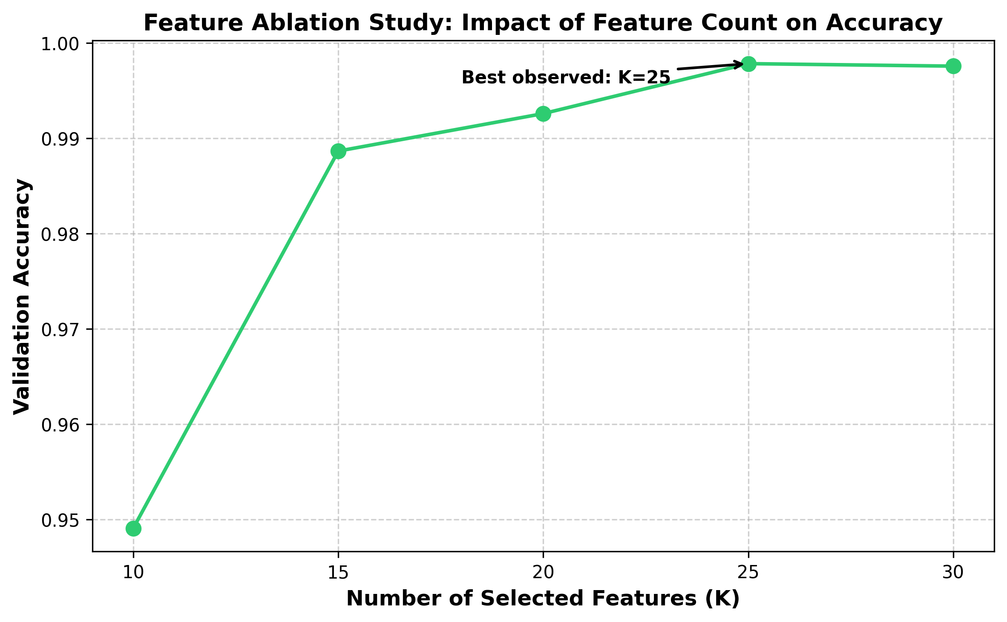
Figure 1. Feature-count ablation. Validation accuracy as a function of the number of selected features; accuracy peaks at K=25 (0.9978) and plateaus thereafter.

3.4. Diversity-Driven Architecture

3.4.1. Motivation: Homogeneous Ensembles Fail
In a preliminary experiment under the identical pipeline (a pilot run, reported here for motivation; it is not part of the released five-fold harness), a soft-voting ensemble of XGBoost, LightGBM, and Random Forest reached weighted F1 = 0.9949, while standalone LightGBM reached 0.9951. The ensemble could not beat its best member: leaf-wise boosters make correlated errors, so averaging them adds nothing. Ensemble gains require error diversity, which motivates the paradigm-diverse design below.

3.4.2. Base Learners
- CatBoost [34]: ordered boosting on symmetric (oblivious) trees, a structurally different boosting scheme from leaf-wise GBDTs.
- ExtraTrees [18]: extremely randomised bagging; randomised split thresholds decorrelate its errors from any boosting member.
- EBM [26,32]: a cyclic-boosted generalised additive model. With interactions disabled (required for multiclass), the model is
$g\left(E\left[y | x\right]\right) = β_{0} + \sum_{j = 1}^{d}{f_{j}\left(x_{j}\right)}$ (5)
So the contribution of feature j to any prediction is exactly f_{j} (x_{j} ); no approximation. EBM is simultaneously a competitive detector (99.34% standalone accuracy, Section 4.1) and the exact-attribution reference on which the explanation-consistency framework of Sections 3.6 and 4.5 rests. LightGBM is retained as the strongest single-model reference row under a standard configuration (Table A); because the central mechanism claim compares voting against stacking over the same three base learners trained on identical folds, it is independent of this reference, which serves only as an external single-model yardstick. The linear baseline (Ridge + Naive Bayes + Passive-Aggressive, soft-voted 1:1:4) from earlier work is kept for continuity.

3.4.3. Combination: Soft Voting vs Stacked Generalisation
Soft voting averages the base probability vectors. Stacked generalisation [40] instead learns when to trust which member: a multinomial logistic-regression meta-learner h is trained on the concatenated base probabilities,
$ŷ = h\left(p_{1}\left(x\right), p_{2}\left(x\right), p_{3}\left(x\right)\right)$ (6)
implemented as blending: within each outer training fold the (resampled) data is split 80/20; bases fit on the 80% part, the meta-learner on the 20% blend part's probabilities. Each base is fitted once per fold, so all reported configurations (standalone members, voting, stacking, and references) share identical folds and identical base fits, making every pairwise statistical test properly paired.

3.5. SOC-Aware Per-Class Threshold Calibration
Argmax over raw probabilities implicitly applies an equal threshold to every class; this is operationally wrong when false-alarm costs differ by class. Machine learning classifiers, including boosted-tree ensembles, are often poorly calibrated, producing distorted probability estimates [19,48]. Before resampling, 10% of each training fold is held out untouched as a calibration slice with real class prevalence (resampled data would mislead the tuning). For each class c, the threshold t_{c} maximising one-vs-rest F1 on the calibration slice is selected from the precision–recall curve, and decisions use threshold moving:
$ŷ = arg \max_{c}\left[\frac{p_{c}\left(x\right)}{t_{c}}\right]$ (7)
The calibration slice is never seen by SMOTE, any base learner, or the meta-learner, so the procedure is leak-free. Learned thresholds are interpretable operating knobs: averaged over folds, BENIGN tunes to 0.21, Web Brute Force to 0.36, XSS to 0.47, FTP-Patator to 0.98, all directly inspectable by SOC engineers.

3.6. The Explanation-Consistency Framework
The framework has three components, none tied to this particular model choice: (1) embed one base learner whose attributions are exact by construction; (2) extract attributions from the post-hoc explainer and from the glass-box member under identical data and identical attribution semantics; and (3) quantify their agreement with formal metrics, treating divergence as a signal to investigate rather than a nuisance. Any ensemble NIDS can adopt the framework by reserving one member slot for a glass-box model; the remainder of this section specifies each component as instantiated here.
SHAP TreeExplainer [28] attributes the CatBoost component's predictions via Shapley values:
$φ_{i}\left(f, x\right) = \sum_{S ⊆ N \backslash \left\{i\right\}}{\frac{\left|S\right|! \left(\left|N\right| - \left|S\right| - 1\right)!}{\left|N\right|!} · \left[f_{x}\left(S ∪ \left\{i\right\}\right) - f_{x}\left(S\right)\right]}$ (8)
Comparability demands identical data and identical attribution semantics on both sides. On the same 1,000 uniformly random background flows (fixed seed) we compute (a) mean absolute SHAP value per feature across samples and classes, and (b) mean absolute exact EBM term contribution per feature via per-sample evaluation of Eq. 5, not EBM's training-set global importances, whose different reference distribution would (and in a pilot, did) depress correlation spuriously. Agreement is quantified with the metrics of Krishna et al. [24]: top-k feature agreement, top-k rank agreement, and Spearman/Kendall rank correlation over all 25 features. Because the background sample is drawn at real class prevalence, it is dominated by majority-class traffic; the agreement statistics therefore characterise global, majority-weighted explanation behaviour. In deployment, analysts receive member-level attributions (SHAP for the CatBoost member, exact terms for the EBM member); the meta-learner is a multinomial logistic regression over member probabilities, so its combination weights are themselves directly inspectable.

3.7. Configuration and Reproducibility
Component | Configuration (as executed)
CatBoost | iterations=200, depth=6, learning_rate=0.1, MultiClass loss, seed=42
ExtraTrees | n_estimators=200, unlimited depth, Gini, seed=42
EBM | max_bins=64, interactions=0, outer_bags=2, max_rounds=2000, per-fold training capped at 100,000 stratified rows, seed=42
Meta-learner | Multinomial logistic regression, max_iter=1000
LightGBM (reference) | n_estimators=100, learning_rate=0.1, max_depth=6
SMOTE | k_neighbors=5 (auto-tuned), per-class cap 50,000, inside folds only
Protocol | Stratified 5-fold CV; per fold: 10% calibration slice, then 80/20 fit/blend split of resampled data; 20% stratified data sample
Table A. Disclosed configuration. The 20% stratified sample (565,563 flows) preserves the full class distribution; the EBM per-fold training cap (100,000 rows) is a scalability measure. Both are disclosed design parameters, reported for full reproducibility; no per-dataset hyperparameter tuning was performed.
The pipeline is implemented in Python using scikit-learn [33] and imbalanced-learn [25], with CatBoost, LightGBM, and InterpretML for the respective models. All timings were measured on an Apple MacBook Pro 14-inch 2023 (M2 Pro, 10-core, 16 GB unified memory, macOS 14 Sonoma), single machine, CPU only; the full five-fold harness completes in 45.7 minutes (40.9 minutes for the UNSW-NB15 harness of Section 4.7).

4. Results and Discussion

4.1. Component Ablation and Headline Performance
Model | Accuracy | F1 (weighted) | F1 (macro) | MCC | Lat. seq (µs) | Lat. par (µs)
Baseline (linear) | 0.8788 | 0.8899 | 0.5024 | 0.6585 | 1.51 | 1.51
LightGBM (reference) | 0.9977 | 0.9980 | 0.8678 | 0.9932 | 12.86 | 12.86
CatBoost | 0.9941 | 0.9953 | 0.8223 | 0.9832 | 0.47 | 0.47
ExtraTrees | 0.9982 | 0.9983 | 0.8989 | 0.9948 | 4.22 | 4.22
EBM | 0.9934 | 0.9950 | 0.8213 | 0.9813 | 0.60 | 0.60
Voting (CB+ET+EBM) | 0.9963 | 0.9971 | 0.8494 | 0.9893 | 5.29 | 4.22
Stacking (CB+ET+EBM) | 0.9983 | 0.9984 | 0.8982 | 0.9951 | 5.41 | 4.33
Stacking + Thresholds | 0.9984 | 0.9984 | 0.8974 | 0.9953 | 5.41 | 4.33
Table 1. Five-fold cross-validated performance (fold means); all rows share identical folds and base fits. Lat. seq assumes sequential member execution; Lat. par assumes members run concurrently (deployment-realistic) plus meta overhead. Macro-F1 here reflects the global feature-ranking pipeline; the leak-free in-fold estimate is 0.8625 (Section 5). Fold-to-fold variability is small: the stacked ensemble’s per-fold macro-F1 ranges from 0.888 to 0.903 (SD 0.006).
Three observations define the headline. First, soft voting fails: at weighted F1 = 0.9971 it beats neither its best member (ExtraTrees, 0.9983) nor the LightGBM reference (0.9980); averaging diverse members of unequal strength dilutes the strong ones. Second, stacking succeeds where voting fails: the meta-learner, having learned when to trust which member, reaches 0.9984 and outperforms every base member and the reference. Third, threshold calibration adds a further small but significant accuracy gain and the best MCC of all configurations (0.9953).

4.1.1. Statistical Validation
Comparison | Discordant pairs (A-only / B-only) | McNemar p | Relative error reduction
Baseline vs Stacking | 405 / 68,017 | ≈ 0 (float underflow) | —
ExtraTrees vs Stacking | 116 / 180 | 2.50×10⁻⁴ | +6.3% (0.180% → 0.169%)
LightGBM vs Stacking | 269 / 643 | 4.80×10⁻³⁵ | +28.1% (0.235% → 0.169%)
Voting vs Stacking | 142 / 1,282 | 3.91×10⁻²⁰⁰ | —
Stacking vs +Thresholds | 79 / 121 | 3.74×10⁻³ | —
Table 2. Pairwise McNemar tests on pooled cross-validated predictions (n = 565,563); every pair shares identical folds. With samples this large, significance is necessary but not sufficient; relative error reductions are reported as effect sizes.
All claimed improvements are statistically significant under McNemar’s test [12,13], recommended for single-dataset classifier comparisons as it controls type I error correctly under properly paired testing. Because the pooled cross-validated predictions aggregate five per-fold models, these tests compare pipelines under identical folds rather than a single fitted classifier. All five comparisons remain significant under a Bonferroni correction for five tests (all p ≤ 3.74×10⁻³). We report effect sizes alongside p-values: the stacked ensemble removes 6.3% of ExtraTrees' residual errors and 28.1% of LightGBM's. These margins are small against the strongest base member and substantial against the strongest external reference. The paper's contribution does not rest on margin size alone but on the diversity mechanism (voting fails, stacking succeeds) and the explainability architecture.

4.2. Per-Class Performance
Attack Class | Precision | Recall | F1 | Support
BENIGN | 1.00 | 1.00 | 1.00 | 454,265
Bot | 0.68 | 0.90 | 0.77 | 391
DDoS | 1.00 | 1.00 | 1.00 | 25,605
DoS GoldenEye | 0.98 | 1.00 | 0.99 | 2,059
DoS Hulk | 1.00 | 1.00 | 1.00 | 46,025
DoS Slowhttptest | 0.99 | 0.99 | 0.99 | 1,100
DoS slowloris | 1.00 | 1.00 | 1.00 | 1,159
FTP-Patator | 1.00 | 1.00 | 1.00 | 1,587
PortScan | 0.99 | 1.00 | 1.00 | 31,761
SSH-Patator | 1.00 | 1.00 | 1.00 | 1,180
Web Attack - Brute Force | 0.69 | 0.57 | 0.63 | 301
Web Attack - XSS | 0.33 | 0.58 | 0.42 | 130
Macro average | 0.89 | 0.92 | 0.90 | 565,563
Table 3. Per-class metrics of the stacked ensemble before threshold calibration, pooled over all five folds (single provenance for every per-class number in this paper; calibrated figures are in Table 5).
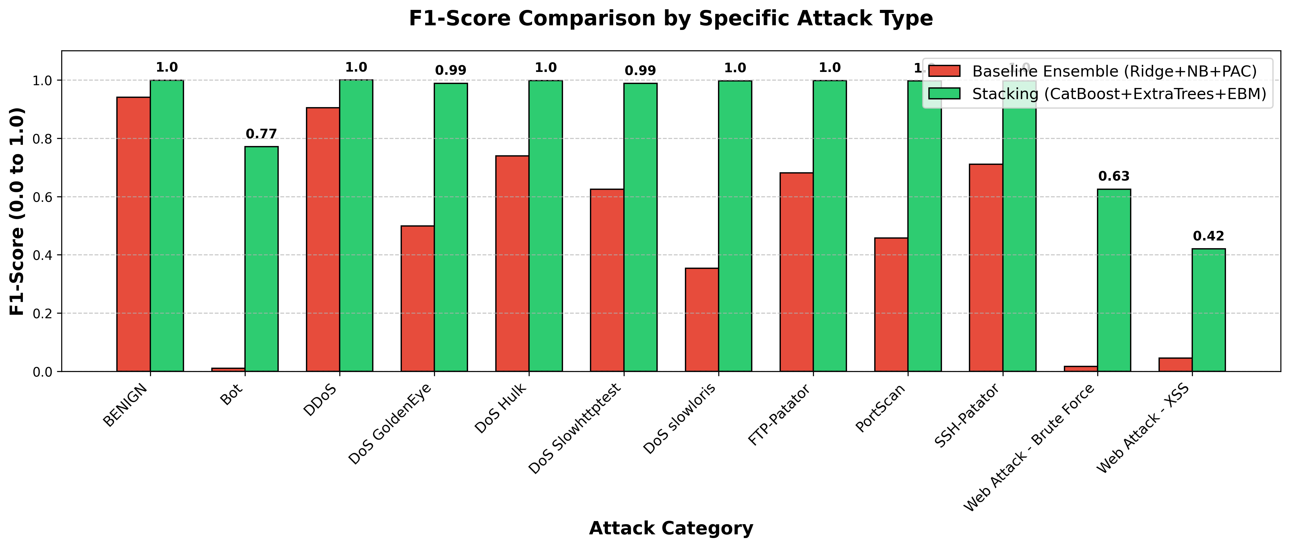
Figure 2. Per-class F1 comparison, linear baseline vs stacked ensemble.
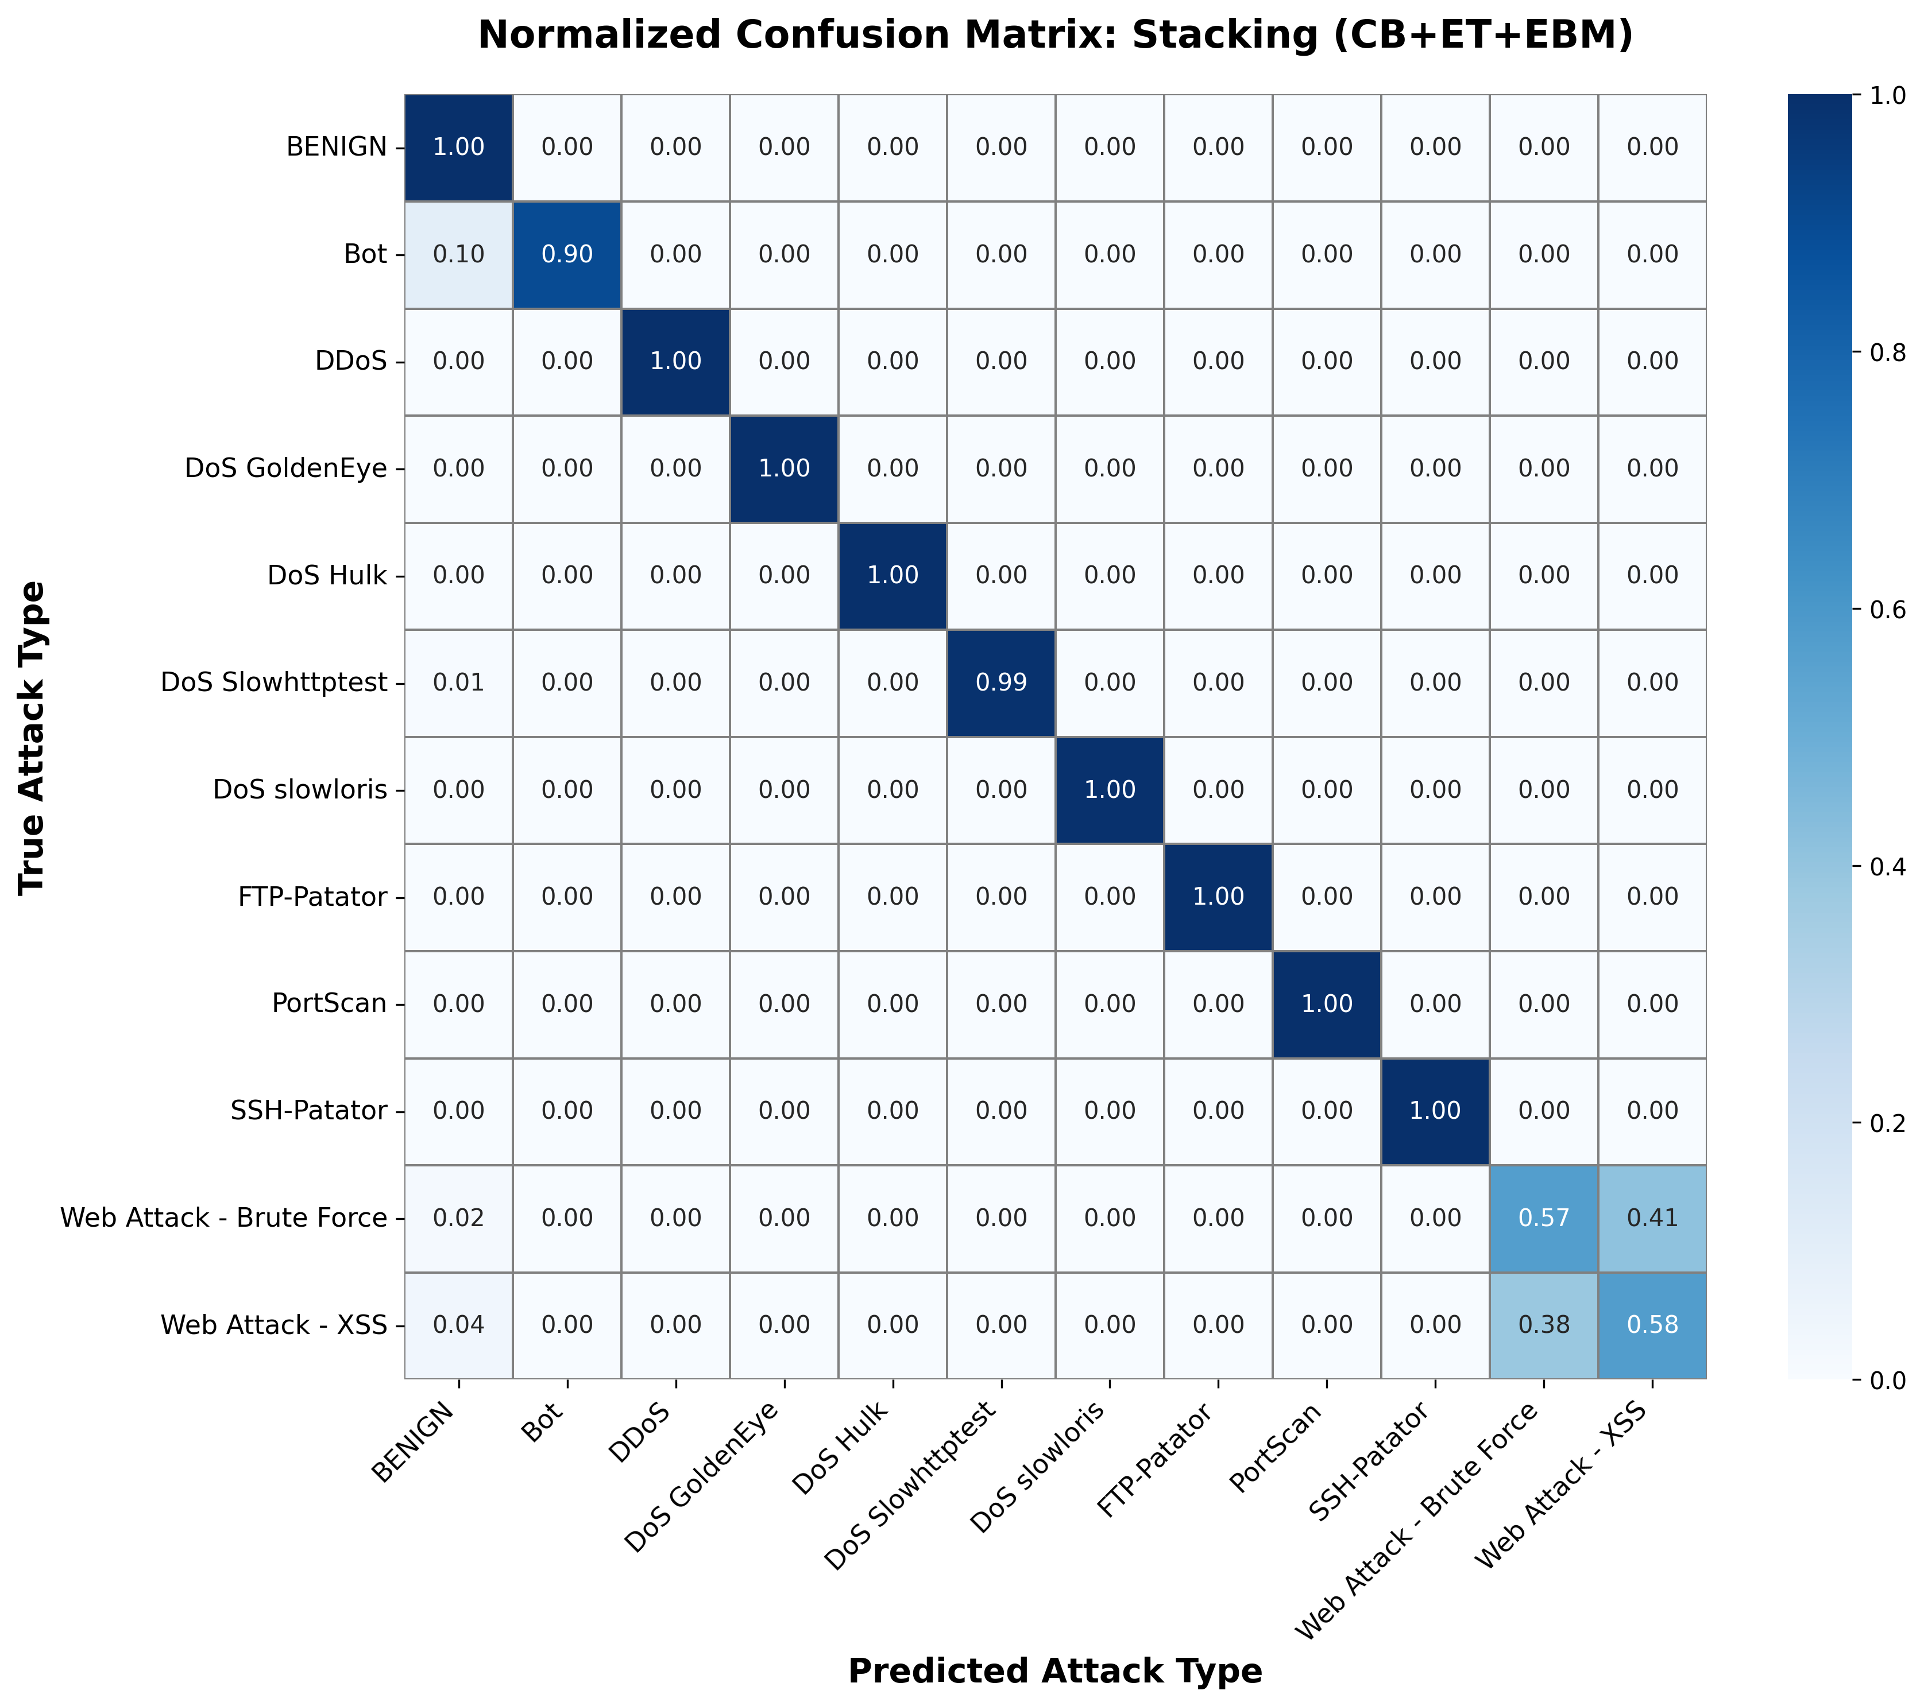
Figure 3. Normalised confusion matrix of the stacked ensemble.

4.3. The Decisive Role of Timing Features for Web Attacks
The most consequential feature-space finding concerns the two rarest web-attack classes. At K=20 features (no inter-arrival-time statistics), XSS managed F1 = 0.09 at precision 0.05 (operationally unusable) and Brute Force F1 = 0.14. Adding the five timing-dominated features at K=25 lifted XSS to F1 = 0.42 (precision 0.33) and Brute Force to F1 = 0.63, improvements of roughly 4.7× and 4.4× from feature selection alone, before any decision-layer intervention. The interpretation is direct: encrypted web attacks overlap heavily with benign traffic in packet-size statistics, but their request timing (inter-arrival patterns) remains discriminative. Flow-based NIDS for payload-hidden attacks should prioritise temporal features; the residual confusion that remains is evidence for deep-packet-inspection-class signals lying outside flow statistics altogether.

4.4. Class-Imbalance Interventions

4.4.1. Resampling: SMOTE vs ADASYN
Class | P (SMOTE) | R (SMOTE) | F1 (SMOTE) | P (ADASYN) | R (ADASYN) | F1 (ADASYN)
Web Attack - Brute Force | 0.588 | 0.565 | 0.576 | 0.610 | 0.598 | 0.604
Web Attack - XSS | 0.247 | 0.554 | 0.342 | 0.267 | 0.477 | 0.343
Table 4. Resampler comparison on the web-attack classes (capped sampling, CatBoost+ExtraTrees evaluator (EBM excluded from this sampler comparison for runtime; disclosed)). ADASYN is modestly favourable for Brute Force and indistinguishable for XSS.
Notably, an identical comparison at K=20 features had produced numerically identical SMOTE and ADASYN results; the samplers only differentiate once timing features give the synthetic points room to matter. Resampler choice is feature-set dependent: at K=20 the two samplers are indistinguishable; at K=25, ADASYN offers a modest benefit for Brute Force on CICIDS-2017. On UNSW-NB15 (at its selected K=30), the relationship reverses: SMOTE outperforms ADASYN on all four focus classes, indicating that ADASYN’s adaptive density estimation benefits depend on the feature-space structure of the target dataset. The binding constraint on minority performance remains feature informativeness, not synthesis strategy.

4.4.2. Decision-Layer Calibration
Class | Stage | Precision | Recall | F1 | False alarms / 100k flows
Bot | before | 0.675 | 0.898 | 0.771 | 29.9
Bot | after | 0.701 | 0.887 | 0.783 | 26.2
Web Attack - Brute Force | before | 0.691 | 0.571 | 0.625 | 13.6
Web Attack - Brute Force | after | 0.656 | 0.658 | 0.657 | 18.4
Web Attack - XSS | before | 0.330 | 0.577 | 0.420 | 26.9
Web Attack - XSS | after | 0.337 | 0.423 | 0.375 | 19.1
Table 5. Effect of per-class threshold calibration on the focus classes (pooled CV predictions). 'Before' = argmax at uniform thresholds; 'after' = thresholds tuned on the untouched real-prevalence calibration slice.
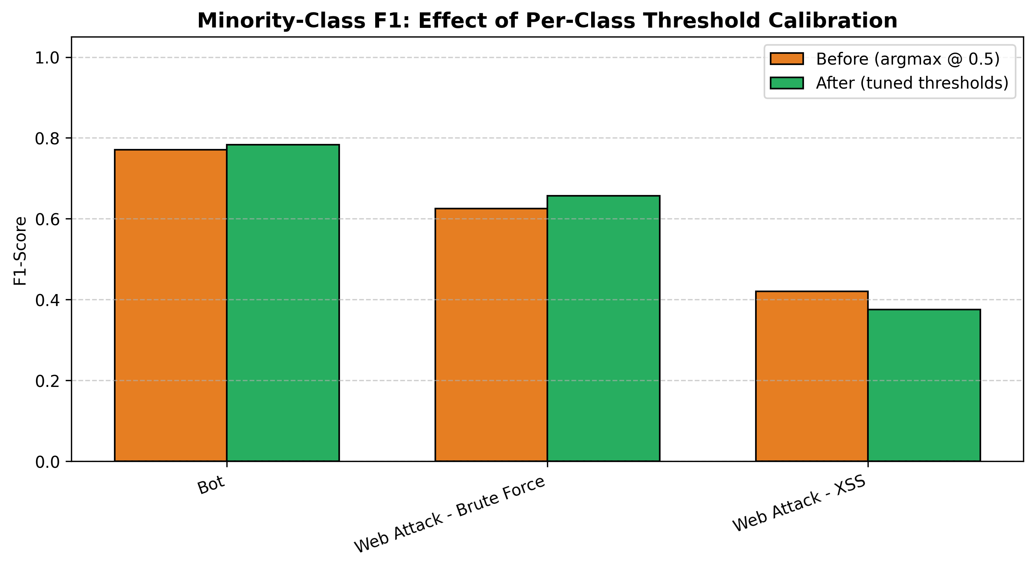
Figure 4. Minority-class F1 before/after threshold calibration.
Calibration is not a uniform trade-off; its effect is class-dependent and operator-meaningful. Bot improves on both precision and false-alarm rate; Brute Force gains F1 (0.625 → 0.657) by accepting more alerts; XSS deliberately trades recall (0.58 → 0.42) to cut false alarms from 26.9 to 19.1 per 100,000 flows. Globally the calibrated system is significantly more accurate (McNemar p = 3.74×10⁻³, Table 2) with the best MCC of all configurations (0.9953). The fold-averaged macro-F1 shows a small decrease (0.8982 → 0.8974, Δ = −0.0008); the pooled-prediction computation gives 0.8981 → 0.8981 (no change), reflecting different aggregation methods within the same pipeline. Calibration improves per-fold macro-F1 in 3 of 5 folds and marginally reduces it in 2. Balanced accuracy also decreases (0.918 → 0.911), the acknowledged cost of the false-alarm reductions in Table 5. The per-class thresholds (e.g., XSS t = 0.47, Brute Force t = 0.36) remain directly inspectable and adjustable by operators per SOC preference.

4.5. Explanation Consistency: Glass-Box vs Post-Hoc
Agreement metric | Value
Top-5 feature agreement | 0.60
Top-5 rank agreement | 0.60
Top-10 feature agreement | 0.90
Top-10 rank agreement | 0.30
Spearman ρ (all 25 features) | 0.775 (p = 5.49×10⁻⁶)
Kendall τ (all 25 features) | 0.620 (p = 3.57×10⁻⁶)
Table 6. Agreement between SHAP attributions (CatBoost component, post-hoc) and exact EBM term contributions, computed on the same 1,000 background flows with identical per-sample attribution semantics. Metrics follow Krishna et al. [24].
The two attribution sets agree on feature identity: 9 of the top-10 features coincide, against an expected chance overlap of 4 of 10 for independent rankings of 25 features, and rank correlation across all 25 features is ρ = 0.775 (p < 10⁻⁵). Positional rank agreement is lower (0.60 top-5, 0.30 top-10, Table 6), so the agreement concerns which features matter more than their exact ordering. Two caveats bound the interpretation. First, SHAP explains the CatBoost member while EBM’s exact terms explain the EBM member, so the comparison spans two different models: agreement provides external corroboration that the attributions reflect signal shared across learning paradigms, not proof that SHAP is faithful to CatBoost’s decision surface. Second, unlike agreement between two post-hoc approximations, this agreement cannot stem from a shared approximation artefact of the explainers; it can, however, still reflect data-level artefacts (for example, label noise [42]) that shape both models. Protocol matters decisively: a pilot comparison of SHAP sample-level attributions against EBM's training-set global importances (mismatched reference distributions) yielded a non-significant ρ = 0.325, which would have been wrongly read as explainer disagreement. We therefore recommend same-sample, same-semantics protocols as standard practice for XAI consistency studies.
The largest divergences are themselves informative: the explainers differ most on Fwd IAT Max and Fwd IAT Mean (SHAP weights are both higher) and Average Packet Size (EBM higher). The IAT features are precisely those carrying interaction effects with other timing features for tree models, which the additive EBM redistributes onto correlated main effects, a known and explicable mechanism rather than an anomaly, and material for analyst guidance on when to prefer which explanation. We note that the attribution of the XSS F1 improvement specifically to IAT statistics rests on feature-group membership rather than a controlled ablation isolating IAT features from other potential additions; the causal mechanism is theoretically motivated and practically consistent with known web-attack traffic patterns, but this caveat should be acknowledged when drawing prescriptive conclusions about feature engineering.
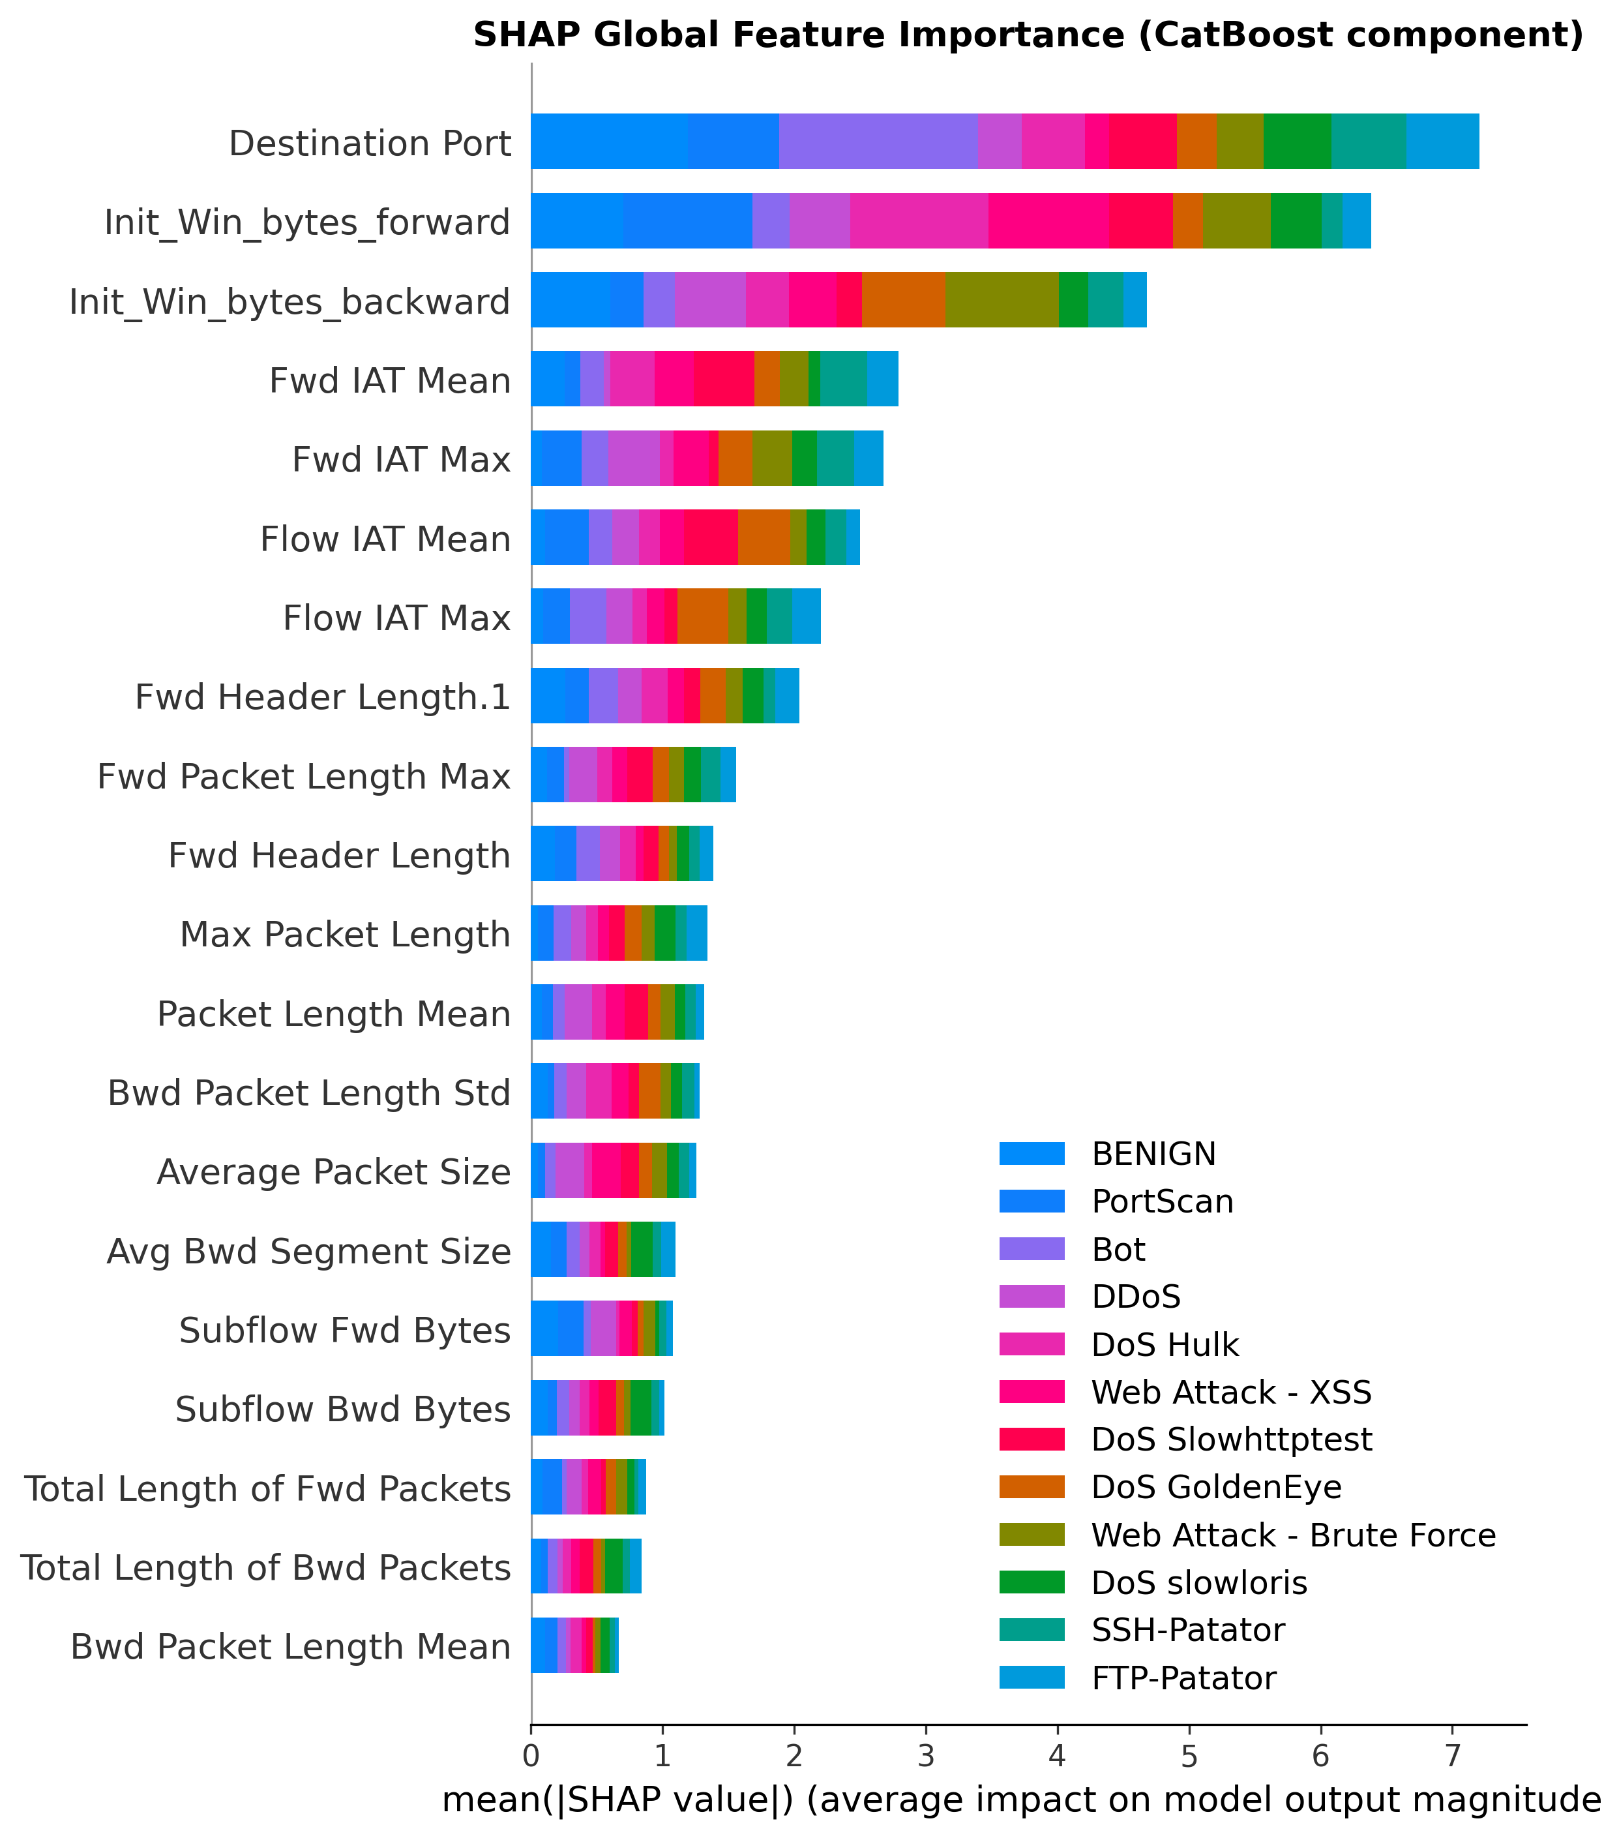
Figure 5a. SHAP global feature importance, CatBoost component, decoded class legend.
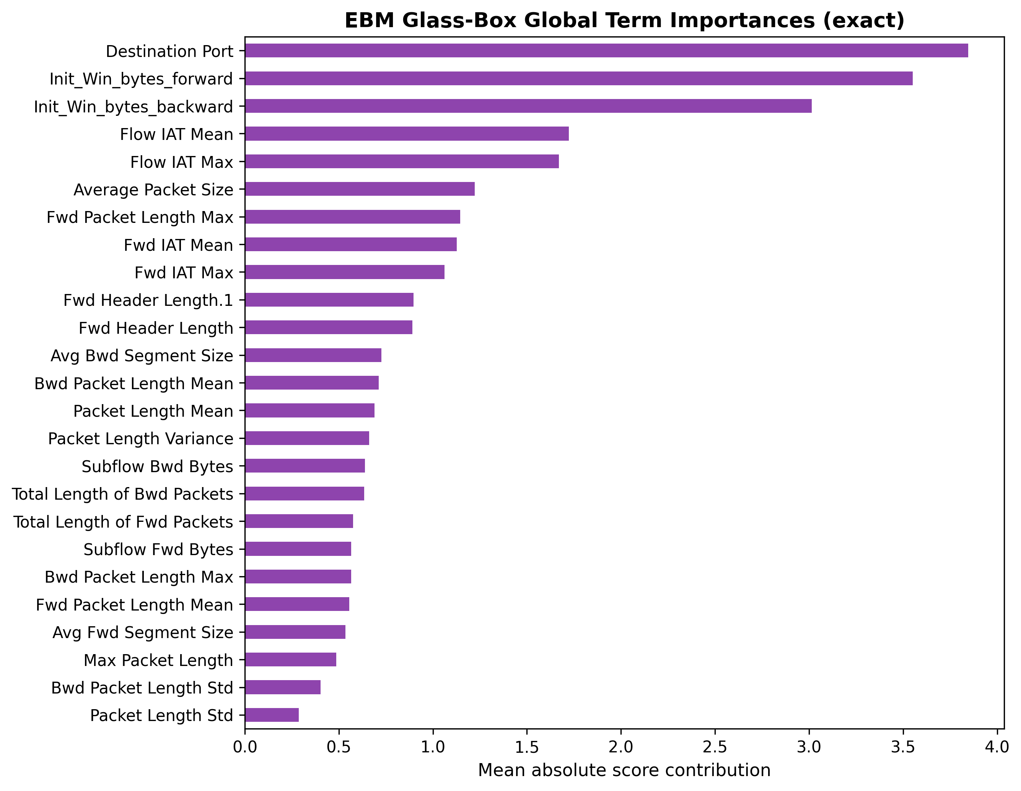
Figure 5b. EBM exact glass-box term importances.
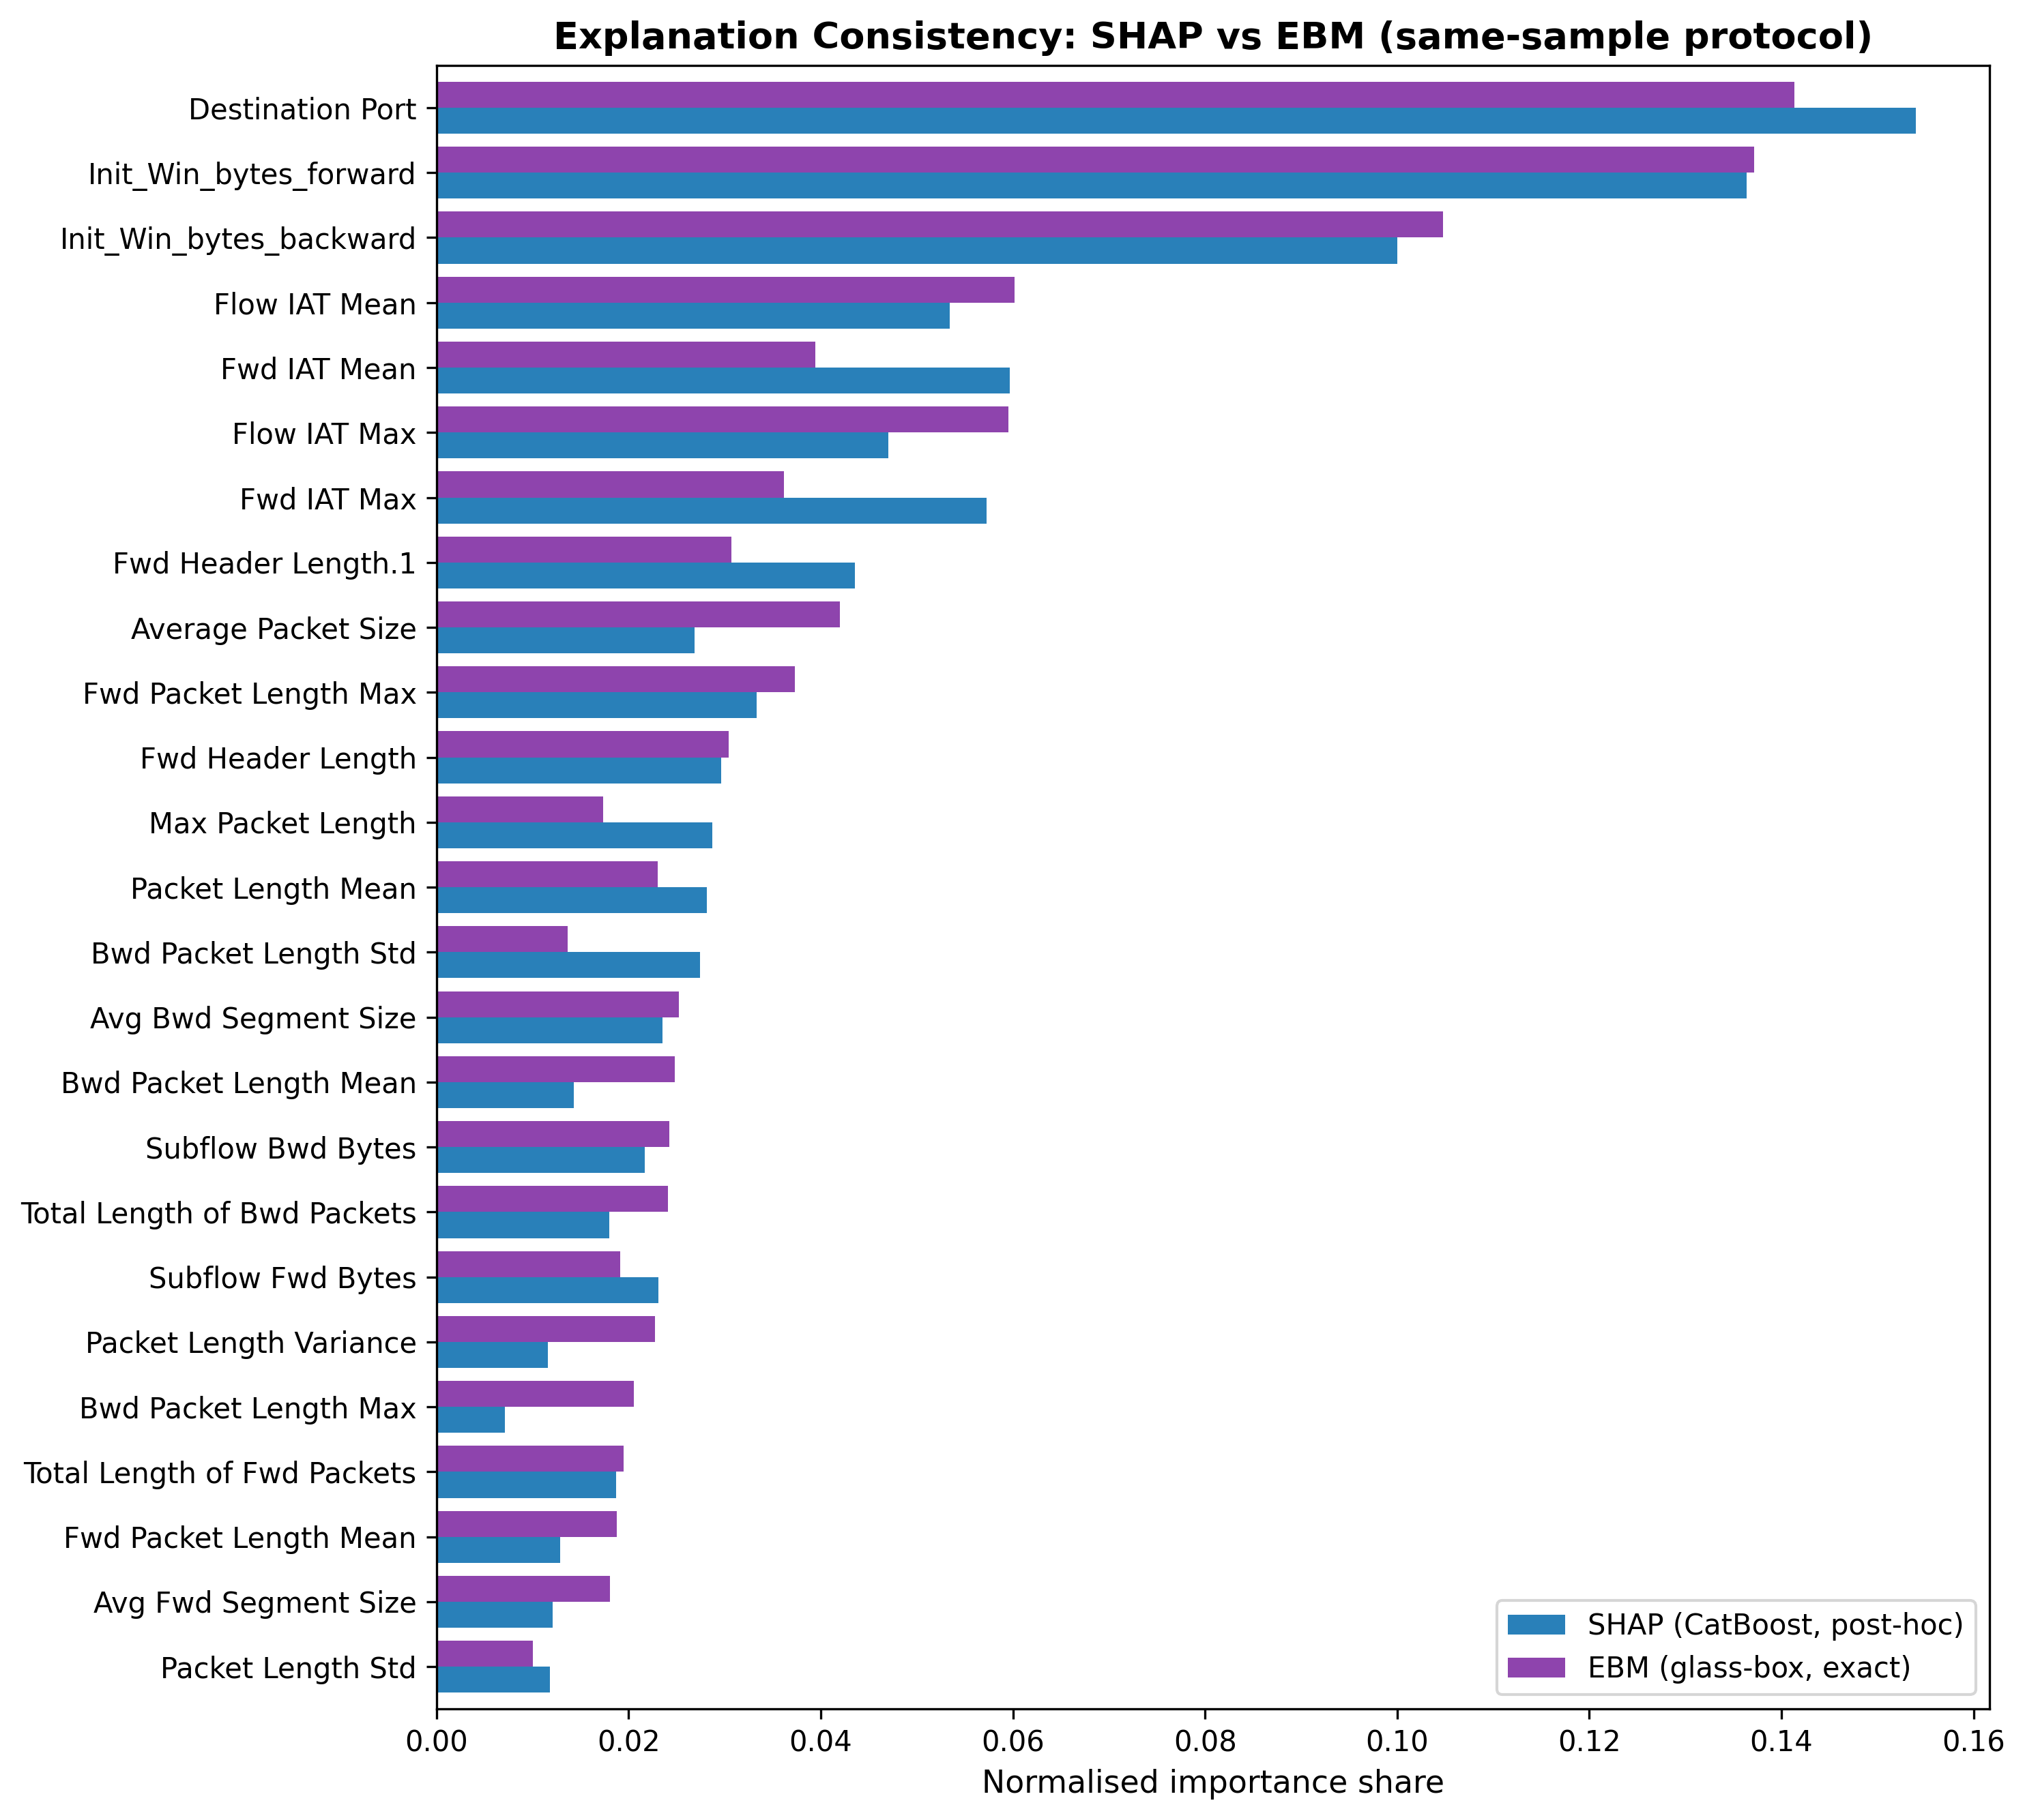
Figure 6. Side-by-side normalised importance shares, SHAP vs EBM, same-sample protocol.
Domain alignment also holds: both explainers rank Destination Port, packet-length statistics (volumetric attack signatures), Init_Win_bytes_forward (SYN-flood window manipulation), and the inter-arrival-time features (web-attack timing) among the most influential, consistent with established threat signatures.

4.5.1. Why an Embedded Glass-Box Member Rather Than Another Post-Hoc Explainer
A reasonable objection is that the reference could have been a second post-hoc explainer, or an interpretable surrogate trained beside the system. Four properties of the embedded glass-box member answer it. First, exactness: the contribution of a feature to an EBM prediction is read directly from its shape function (Eq. 5), so one side of the consistency comparison carries no approximation error; agreement between two post-hoc methods, by contrast, can always be co-produced by a shared approximation artefact [24,36], which is precisely the regress the framework removes. Second, deployment locality: the reference is a load-bearing member of the detector, not a shadow model maintained beside it. It is trained on the same folds, sees the production feature space, and returns its attributions at decision time for the same 0.60 µs member cost already paid for detection (Table 1); an offline surrogate can drift out of sync with the deployed system, whereas a base learner cannot. Third, the reference is free at the accuracy level as well: EBM is a competitive detector on its own (99.34% accuracy, Table 1), and the stack containing it outperforms every base member and the external reference (Section 4.1), so interpretability is not being purchased with detection performance, the usual objection to deploying glass-box models alone. Fourth, the same machinery doubles as an operational monitor: the agreement metrics of Table 6 can be recomputed on any window of live traffic, giving a SOC a standing, quantitative check that the explanations it acts on still track an exact reference; a fall in agreement is an inspectable alarm, whether the cause is distribution drift or explainer failure.
None of this argues for abandoning post-hoc explanation. SHAP remains the appropriate instrument for the tree members, and a glass-box-only detector would give up the accuracy the heterogeneous ensemble buys (Table 1); Rudin’s case for inherently interpretable models [37] is answered here not by rejecting the black-box members but by making one interpretable member structural. The claim is narrower and operational: when a deployed system attaches explanations to black-box components, embedding one glass-box member converts explanation trust from an assumption into a measured, monitorable property.

4.6. Computational Efficiency
With base members executed concurrently (natural in deployment, as the three models are independent), stacked inference costs 4.33 µs/sample on CICIDS-2017 (sequential: 5.41 µs), a throughput of roughly 231,000 flows per second per core group on commodity Apple-silicon hardware. On UNSW-NB15, where ExtraTrees is slower over a larger feature set, parallel stacking latency is 29.8 µs, still within real-time requirements at typical enterprise traffic rates. The meta-learner adds negligible overhead in both cases. Figure 7 places every configuration on the accuracy–latency plane: CatBoost and EBM are exceptionally cheap (0.47 and 0.60 µs), ExtraTrees costs 4.22 µs, and LightGBM is the slowest at 12.86 µs; the stacked ensemble is simultaneously more accurate and 2.97× faster than the LightGBM reference at parallel latency. Training the full five-fold harness takes 45.7 minutes on CICIDS-2017 and 40.9 minutes on UNSW-NB15.
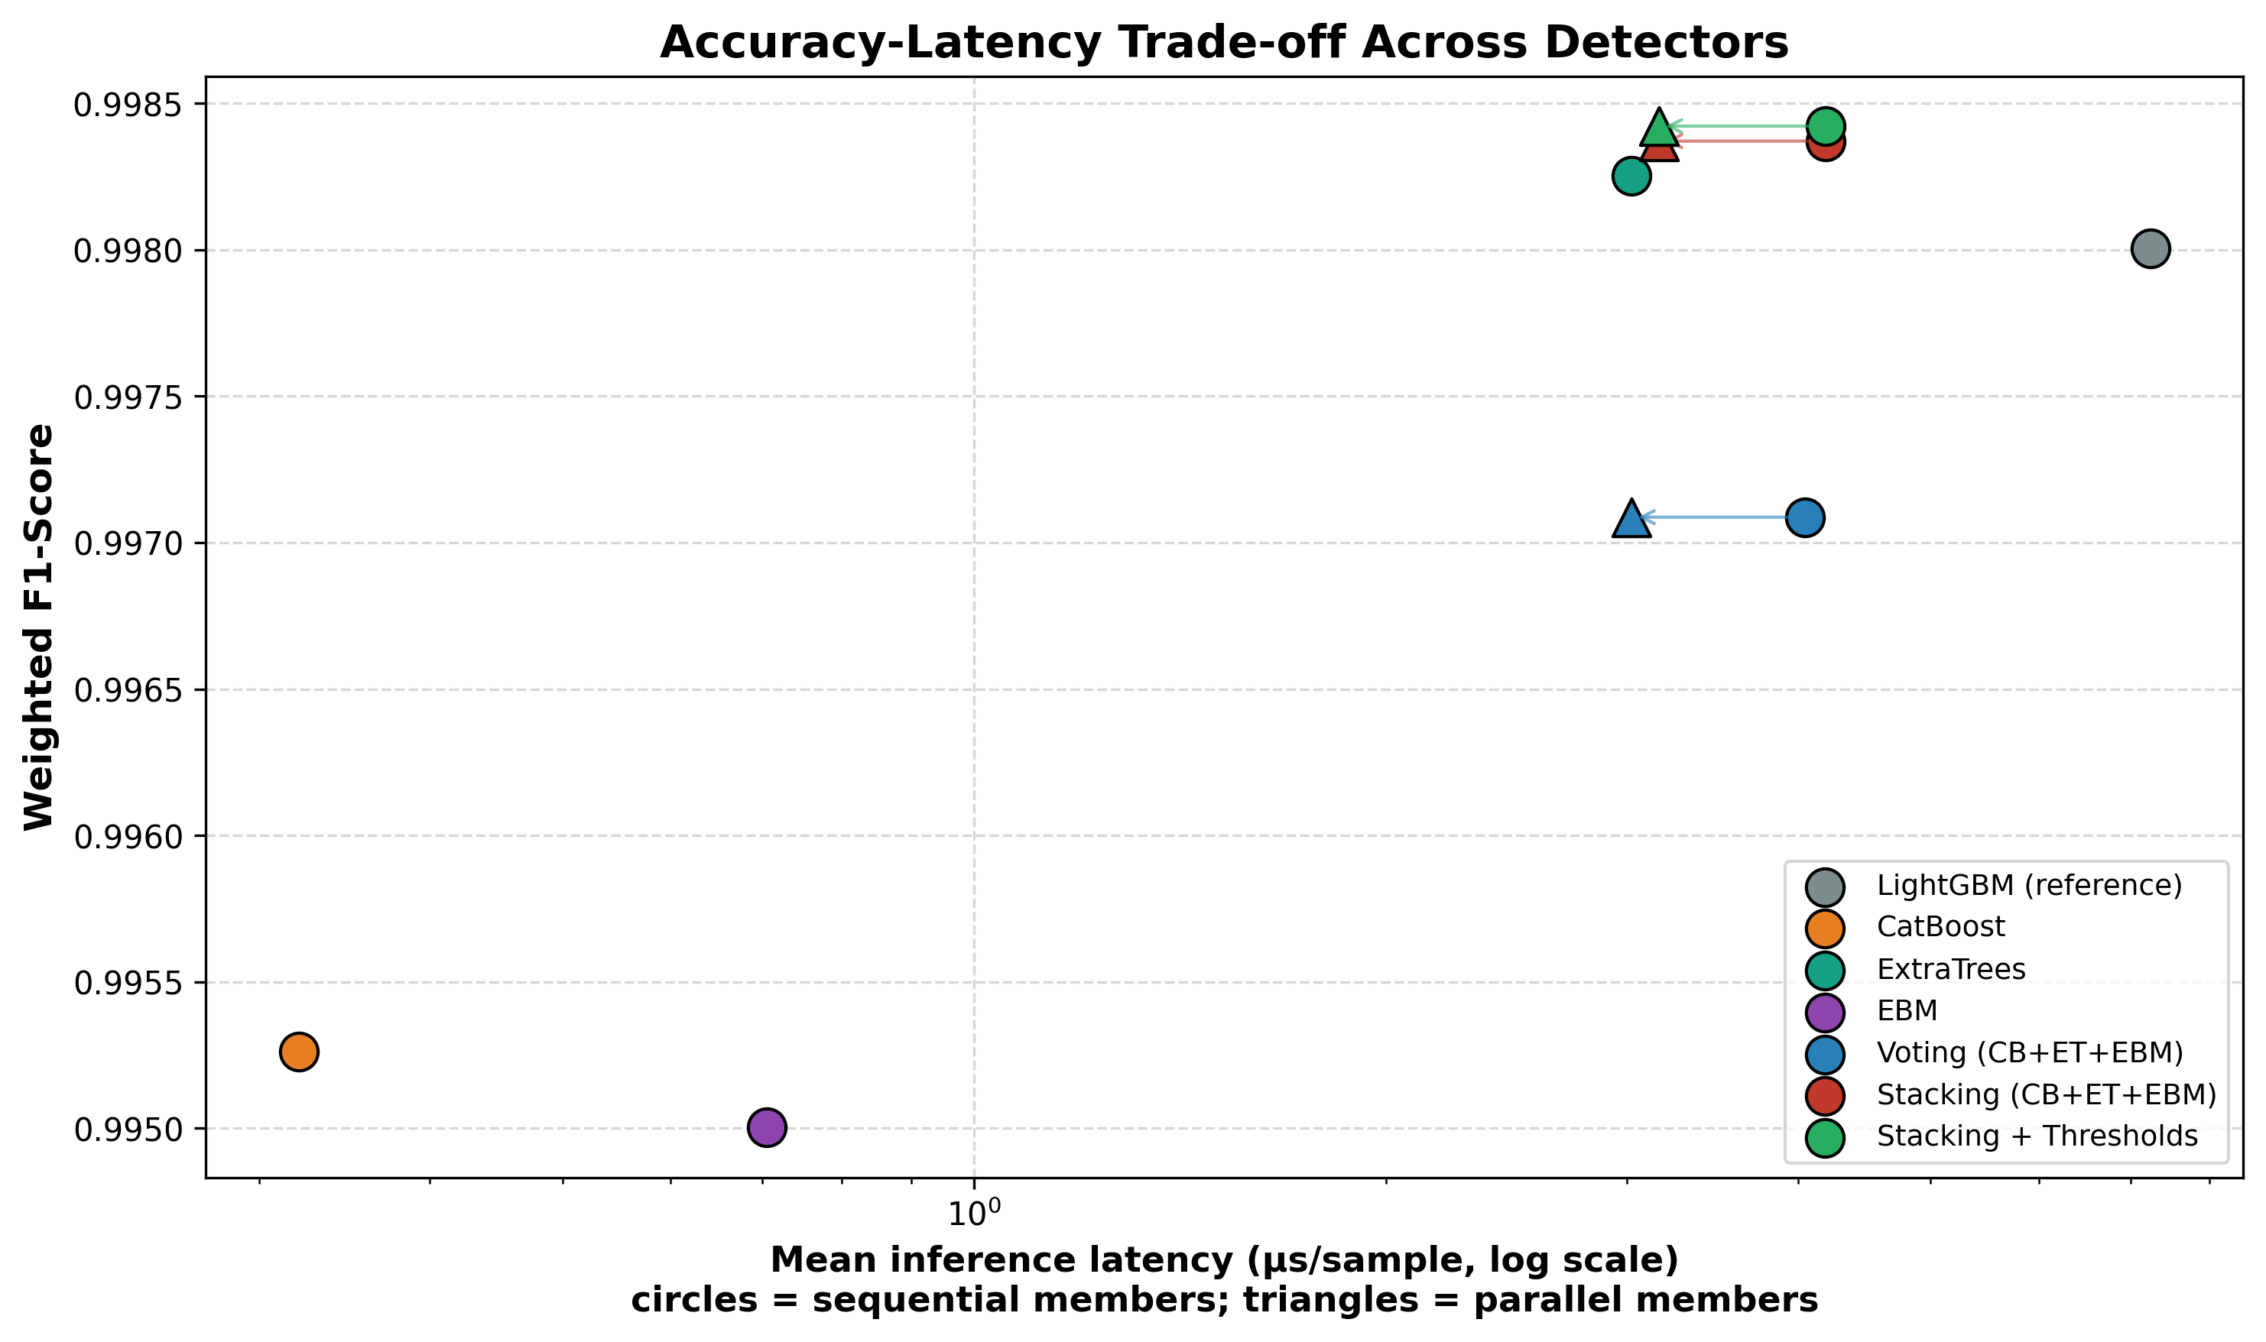
Figure 7. Accuracy–latency trade-off (log-scale latency); circles = sequential members, triangles = parallel execution.

4.7. Cross-Dataset Validation on UNSW-NB15
To test whether the findings are artefacts of a single benchmark, the entire pipeline (feature ranking, capped leak-proof SMOTE, the three-paradigm stacked ensemble, threshold calibration, paired McNemar testing, and the SHAP-versus-EBM agreement study) was re-run natively (retrained and re-evaluated) on UNSW-NB15 [30]: 257,673 flows obtained by pooling the two official UNSW-NB15 partitions (175,341 training-set and 82,332 testing-set flows), 42 features after categorical encoding, 10 classes, evaluated by the same 5-fold stratified CV protocol used for CICIDS-2017. This differs from the official UNSW-NB15 train/test split used in some published benchmarks; the protocol was chosen for consistency and variance stability rather than direct comparability to the state-of-the-art literature on UNSW. UNSW-NB15 is generated by a different feature-extraction toolchain (Argus and Bro/Zeek flow statistics) than CICIDS-2017's CICFlowMeter, so replication across the two provides evidence that the architecture’s behaviour is not specific to one feature-extractor family. The feature-count ablation independently selected K=30 on UNSW-NB15 (versus K=25 on CICIDS-2017; each dataset’s own ablation maximum was adopted), and all model hyperparameters were held identical to the CICIDS-2017 configuration (Table A).
Model | Accuracy | F1 (weighted) | F1 (macro) | MCC | Lat. par (µs)
Baseline (linear) | 0.5479 | 0.6128 | 0.2891 | 0.4828 | 1.21
LightGBM (reference) | 0.8024 | 0.8131 | 0.5766 | 0.7535 | 8.93
CatBoost | 0.7770 | 0.7937 | 0.5385 | 0.7259 | 0.31
ExtraTrees | 0.8106 | 0.8191 | 0.5760 | 0.7594 | 29.68
EBM | 0.7720 | 0.7878 | 0.5306 | 0.7174 | 0.61
Voting (CB+ET+EBM) | 0.7999 | 0.8114 | 0.5565 | 0.7502 | 29.68
Stacking (CB+ET+EBM) | 0.8141 | 0.8206 | 0.5817 | 0.7618 | 29.8
Stacking + Thresholds | 0.8174 | 0.8210 | 0.5840 | 0.7644 | 29.8
Table 7. Five-fold cross-validated performance on UNSW-NB15, identical pipeline and hyperparameters to the CICIDS-2017 run. The central mechanism replicates: voting fails to beat the best base member, stacking succeeds.
The diversity-driven mechanism replicates cleanly. Soft voting (weighted F1 = 0.8114) again fails to beat its best member, ExtraTrees (0.8191), whereas stacking (0.8206) beats ExtraTrees (McNemar p = 1.69×10⁻²⁵; +1.8% relative error reduction, 18.94→18.60% error) and the LightGBM reference (0.8131; p = 1.08×10⁻⁹⁷, +5.9% relative error reduction). The ExtraTrees effect size (1.8%) is smaller than on CICIDS-2017 (6.3%), a difference expected given the greater class overlap in UNSW-NB15; the directional claim is preserved on both benchmarks. Threshold calibration then raises accuracy to 0.8174 and macro-F1 to 0.5840 (p = 2.93×10⁻¹⁹), again posting the best MCC of all configurations (0.7644). The absolute scores are lower than on CICIDS-2017, as expected: UNSW-NB15 is a deliberately harder benchmark whose Analysis, Backdoor, and DoS classes overlap heavily in feature space. The relative ordering of methods, however, is preserved exactly; the architectural claim is benchmark-independent.
Threshold calibration is markedly more impactful on the harder benchmark. Where CICIDS-2017's well-separated classes left little room for decision-layer tuning, UNSW-NB15's overlapping classes show class-specific calibration effects (Table 8): Analysis precision rose sharply from 0.12 to 0.39 and false alarms fell from 992.3 to 166.5 per 100,000 flows (an 83% reduction), the dominant improvement. Backdoor false alarms fell modestly from 759.5 to 686.9 per 100,000 flows while Backdoor recall improved (0.115→0.139) — unlike Analysis, whose recall fell (0.131→0.103) as precision rose. Worms and Shellcode each showed smaller false-alarm reductions. Macro-F1 improved slightly (pooled predictions: 0.5814→0.5839; fold-averaged, as in Table 7: 0.5817→0.5840), while balanced accuracy decreased (0.5860→0.5754) due to the recall-for-precision trade on Analysis. Whether this trade is operationally acceptable depends on the priority assigned to these attack classes in the deployment context; the calibration thresholds are adjustable per operator preference, which is precisely the operational flexibility the leak-free calibration mechanism provides.
Class | Stage | Precision | Recall | F1 | False alarms / 100k
Worms | before | 0.443 | 0.425 | 0.434 | 36.1
Worms | after | 0.447 | 0.391 | 0.417 | 32.6
Shellcode | before | 0.568 | 0.635 | 0.600 | 282.5
Shellcode | after | 0.569 | 0.621 | 0.594 | 275.5
Backdoor | before | 0.120 | 0.115 | 0.118 | 759.5
Backdoor | after | 0.154 | 0.139 | 0.146 | 686.9
Analysis | before | 0.120 | 0.131 | 0.125 | 992.3
Analysis | after | 0.391 | 0.103 | 0.163 | 166.5
Table 8. UNSW-NB15 threshold calibration on the four rarest classes (auto-selected). The benefit is far larger than on CICIDS-2017 because the benchmark's class overlap leaves more headroom for decision-layer correction.
Explanation-consistency: partial replication. Under the same-sample protocol, Spearman ρ = 0.840 (p = 6.31×10⁻⁹) and Kendall τ = 0.632 on UNSW-NB15, stronger than CICIDS-2017 (ρ = 0.775). Top-10 feature agreement is 0.9 on CICIDS-2017 and 0.8 on UNSW-NB15 (Table 9). However, top-5 feature agreement falls to 0.4 on UNSW (vs 0.6 on CICIDS), and top-5 positional rank agreement is 0.2 and top-10 rank agreement is 0.1 on UNSW (vs 0.6 and 0.3 on CICIDS, respectively). The weaker rank metrics on UNSW reflect higher co-linearity among Argus/Zeek flow statistics: connection-count features (ct_src_dport_ltm, ct_dst_src_ltm) dominate EBM contributions but not SHAP attributions, and an additive GAM redistributes these across correlated main effects differently from Shapley values. The result is nuanced: global rank correlation is significant on both benchmarks and corroborates the SHAP explanations delivered to analysts; positional rank agreement does not generalise across feature-extractor families. Practitioners should apply SHAP-vs-glass-box consistency checks per deployment context.
Agreement metric | UNSW-NB15 | CICIDS-2017
Top-5 feature agreement | 0.40 | 0.60
Top-5 rank agreement | 0.20 | 0.60
Top-10 feature agreement | 0.80 | 0.90
Top-10 rank agreement | 0.10 | 0.30
Spearman ρ | 0.840 (p = 6.31×10⁻⁹) | 0.775 (p = 5.5×10⁻⁶)
Kendall τ | 0.632 (p = 1.23×10⁻⁷) | 0.620 (p = 3.57×10⁻⁶)
Table 9. UNSW-NB15 explanation-agreement metrics vs CICIDS-2017. ρ is stronger on UNSW; positional rank agreement does not transfer. Figures U1–U7 mirror the CICIDS-2017 panels for UNSW-NB15: ablation (U1), per-class F1 (U2), confusion matrix (U3), SHAP importance (U4), explanation agreement (U5), latency–Pareto (U6), and threshold calibration (U7). The EBM-importances panel (Figure 5b for CICIDS-2017) is omitted for UNSW-NB15.
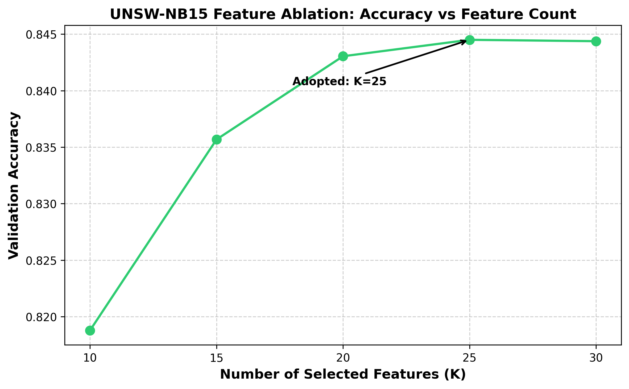
Figure U1. Feature-count ablation on UNSW-NB15.
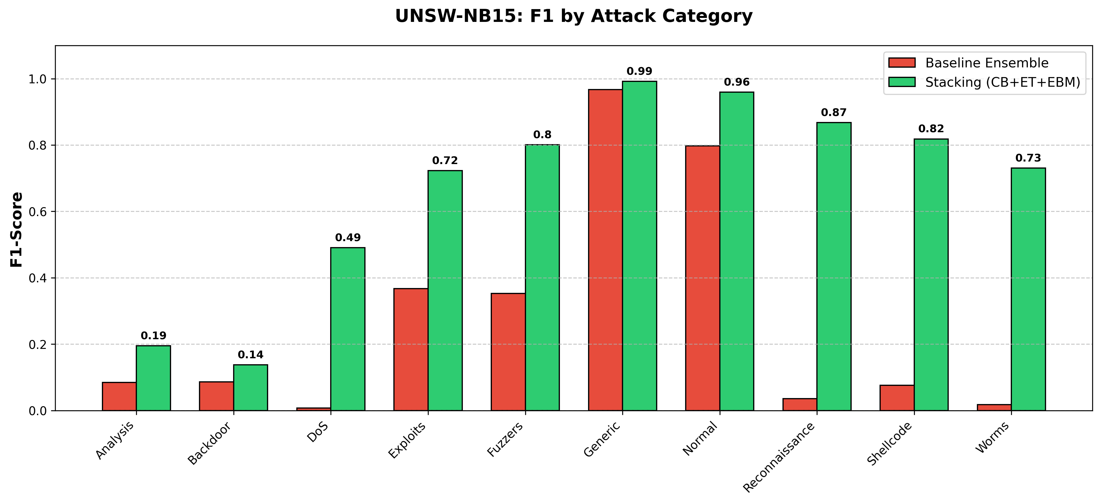
Figure U2. Per-class F1, baseline vs stacked ensemble (UNSW-NB15).
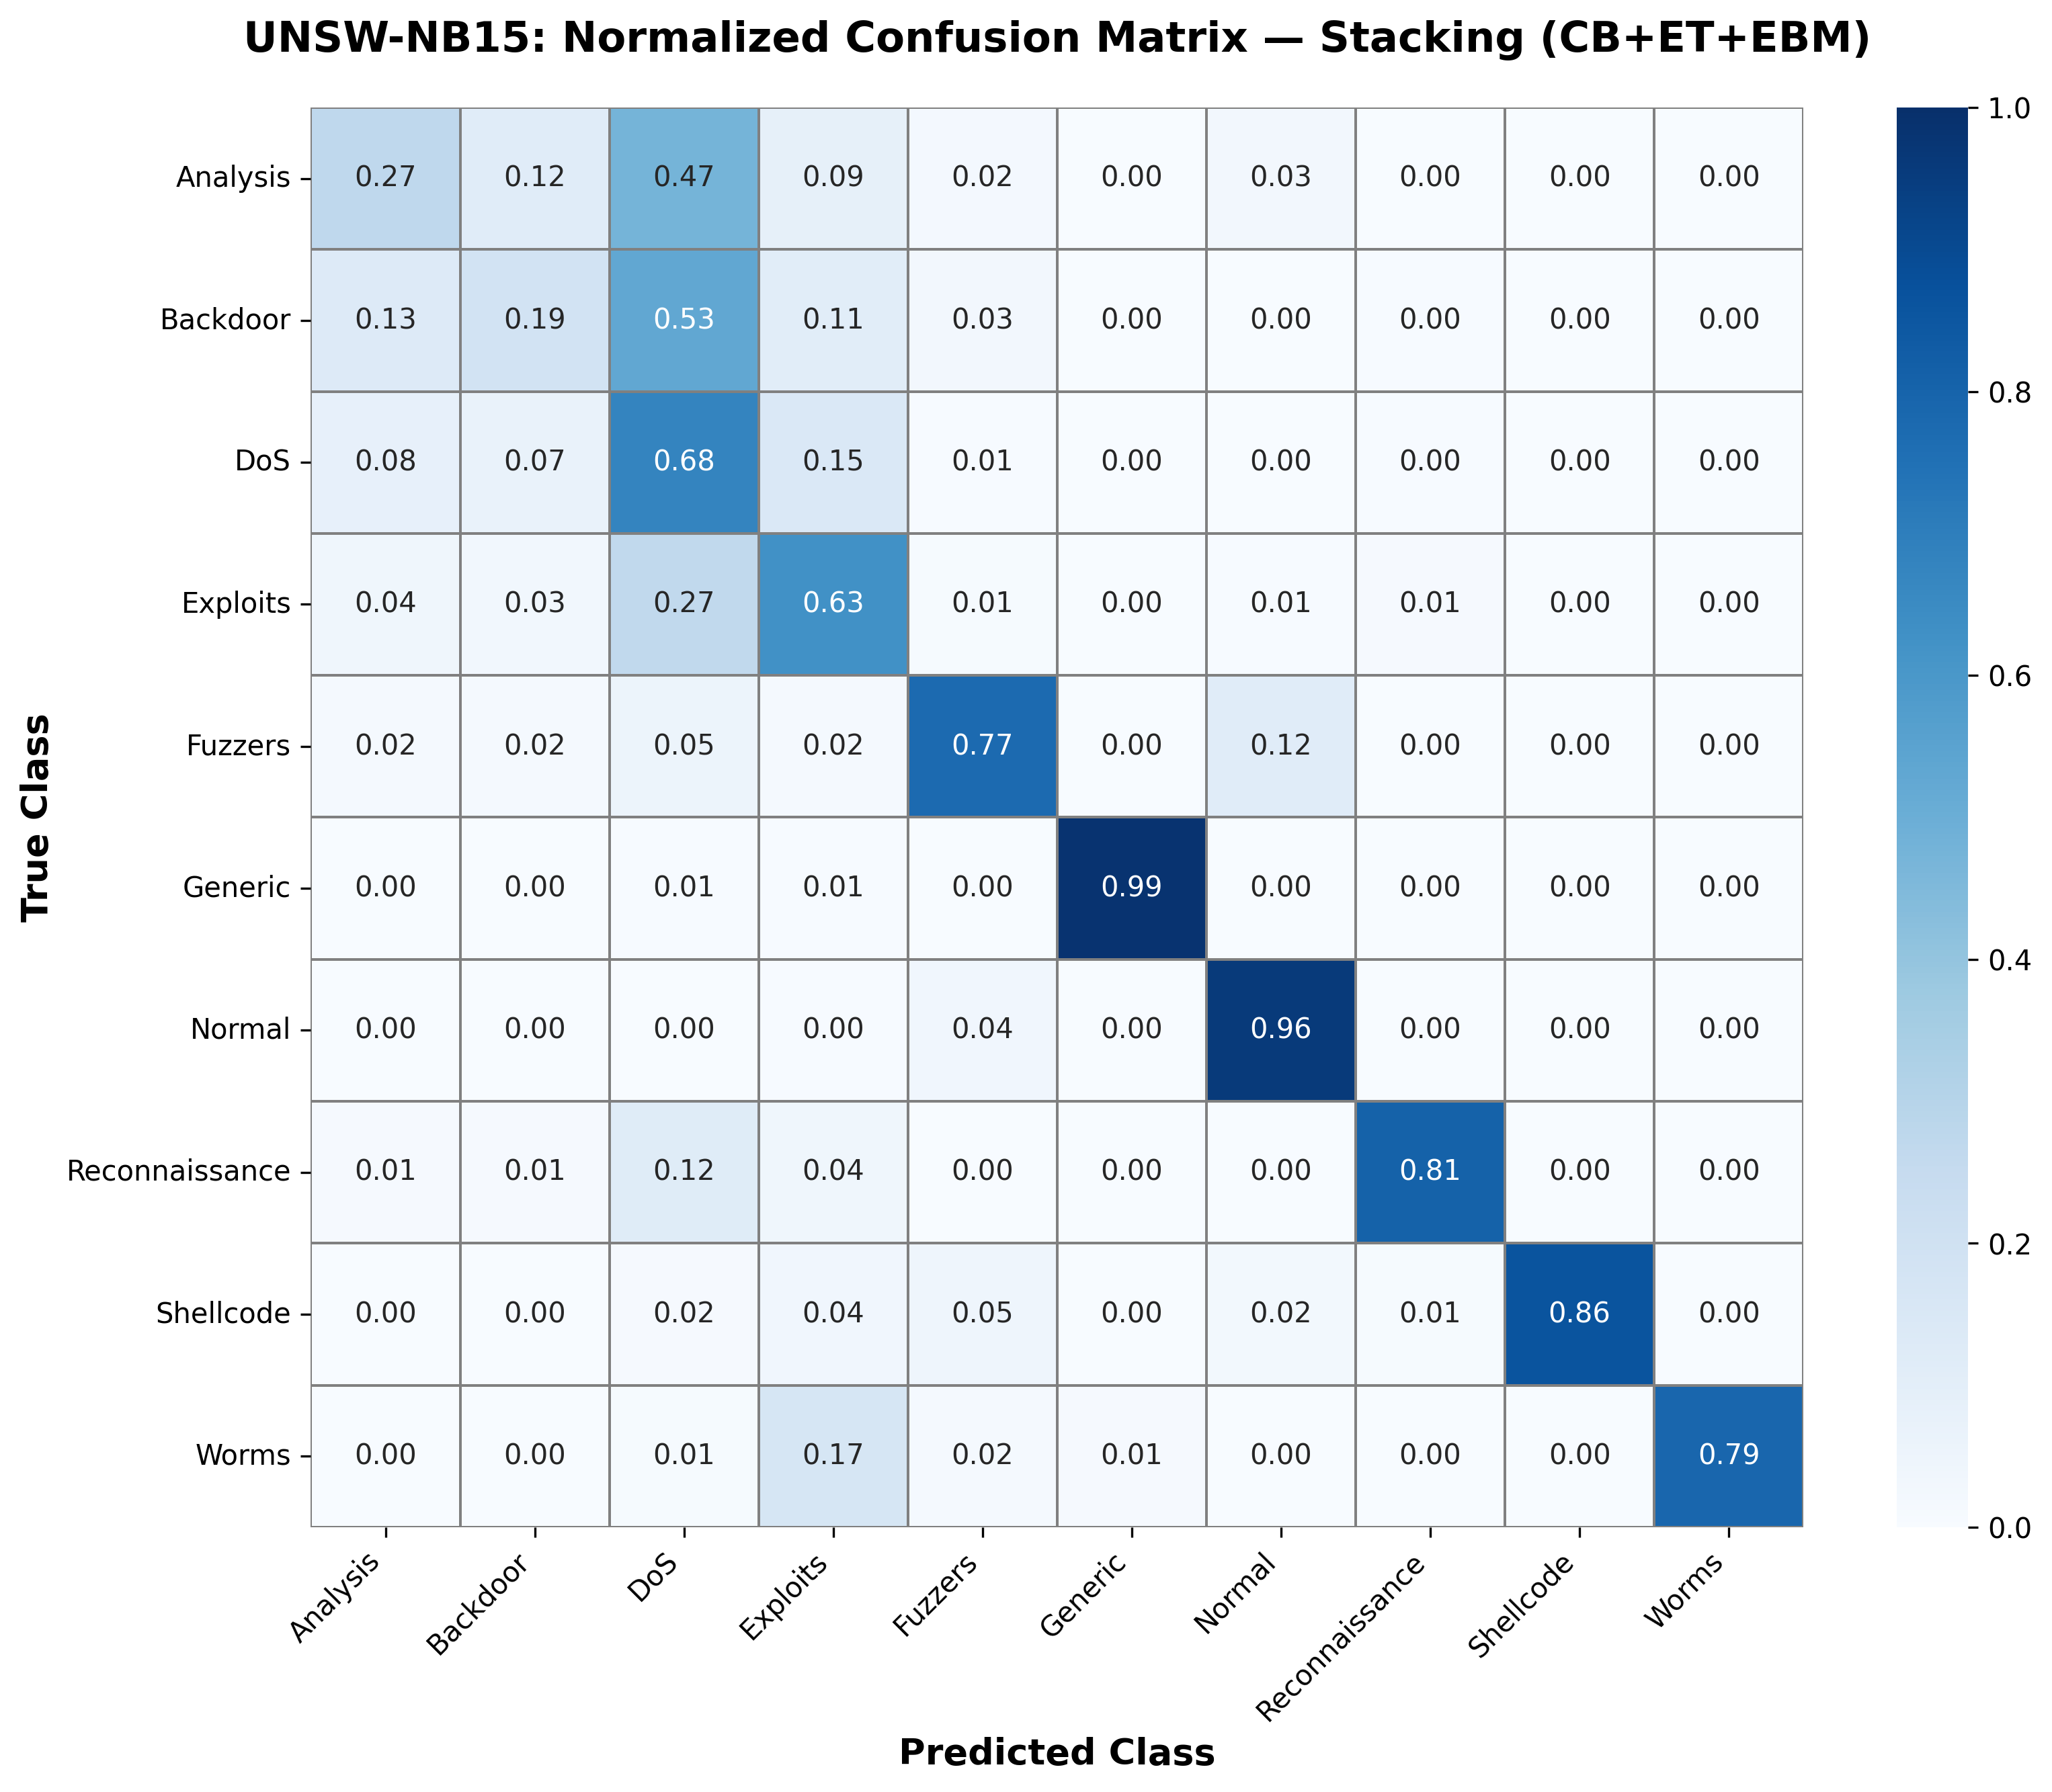
Figure U3. Normalised confusion matrix of the stacked ensemble (UNSW-NB15).
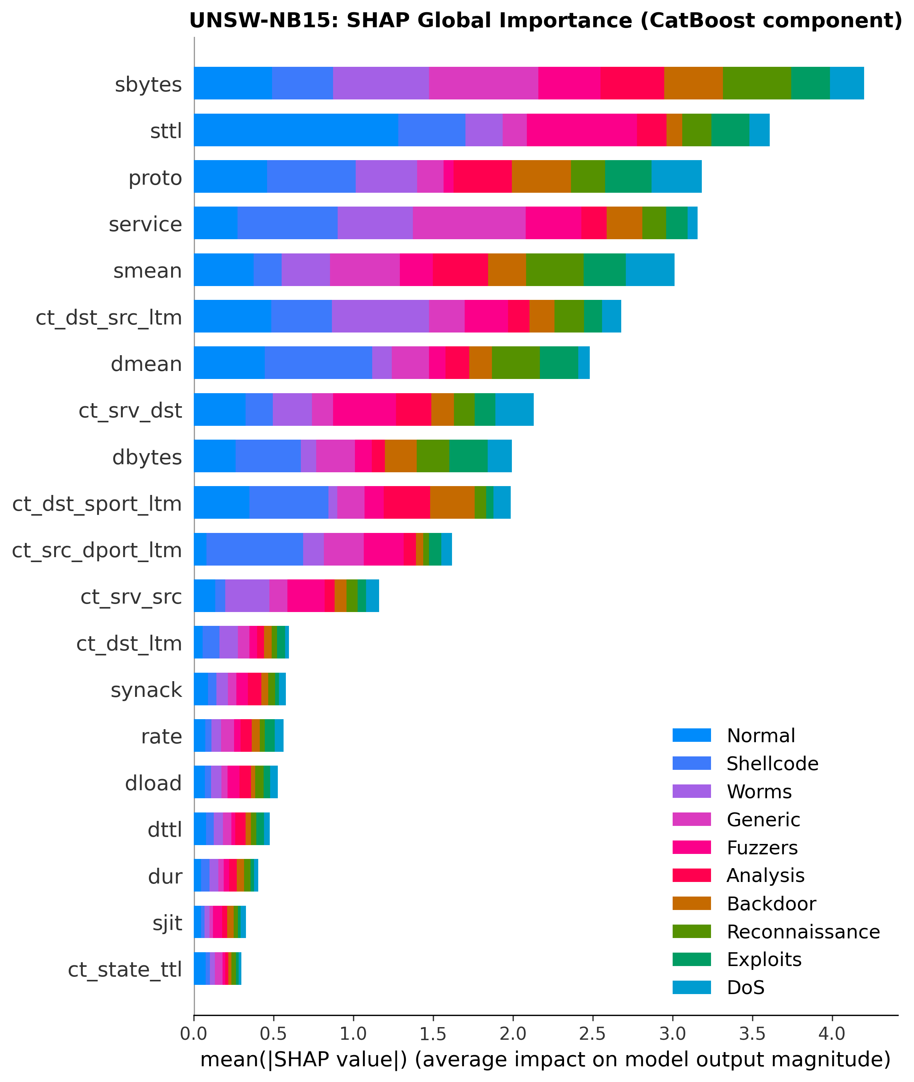
Figure U4. SHAP global feature importance, CatBoost component (UNSW-NB15).
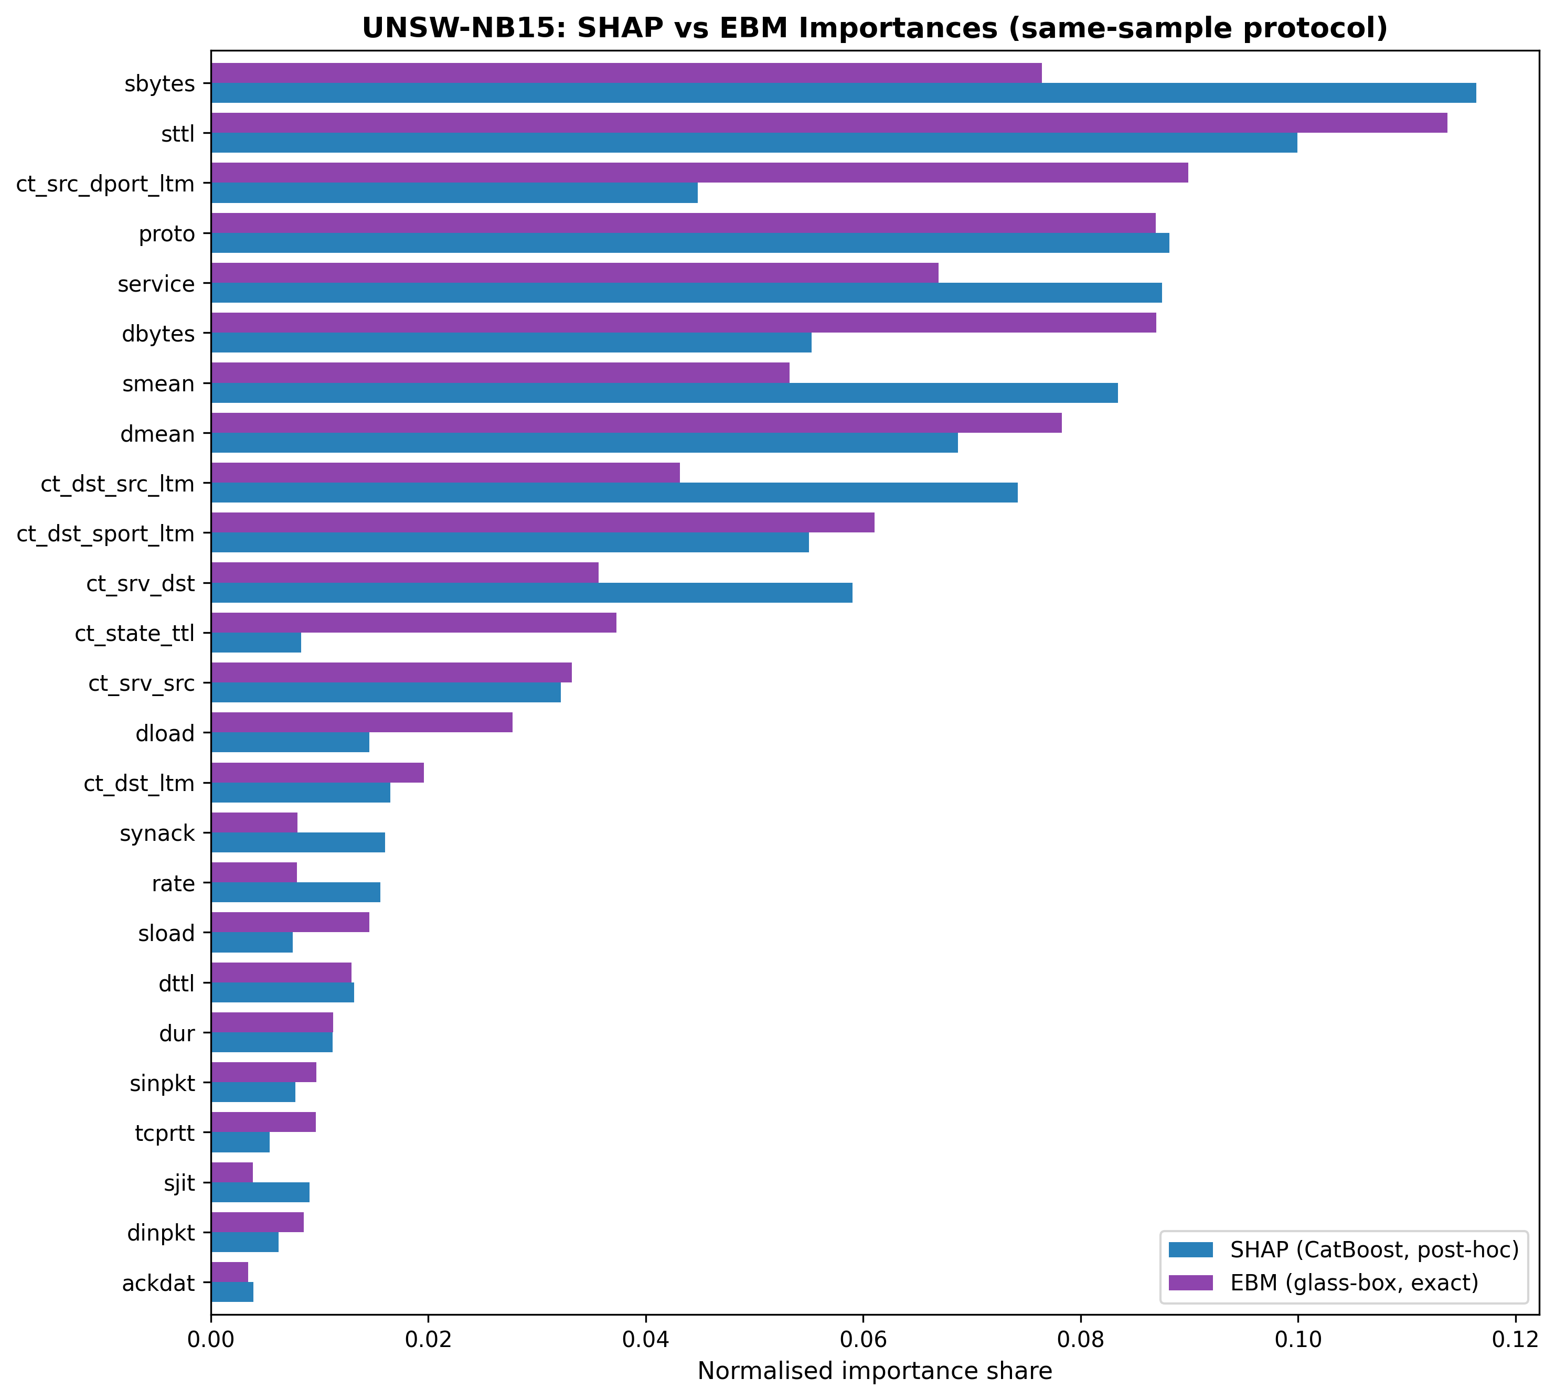
Figure U5. Normalised importance shares, SHAP vs EBM (UNSW-NB15).
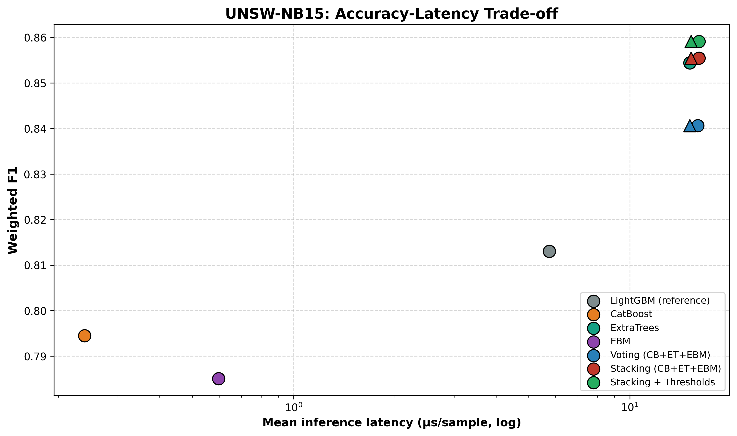
Figure U6. Accuracy–latency trade-off (UNSW-NB15).
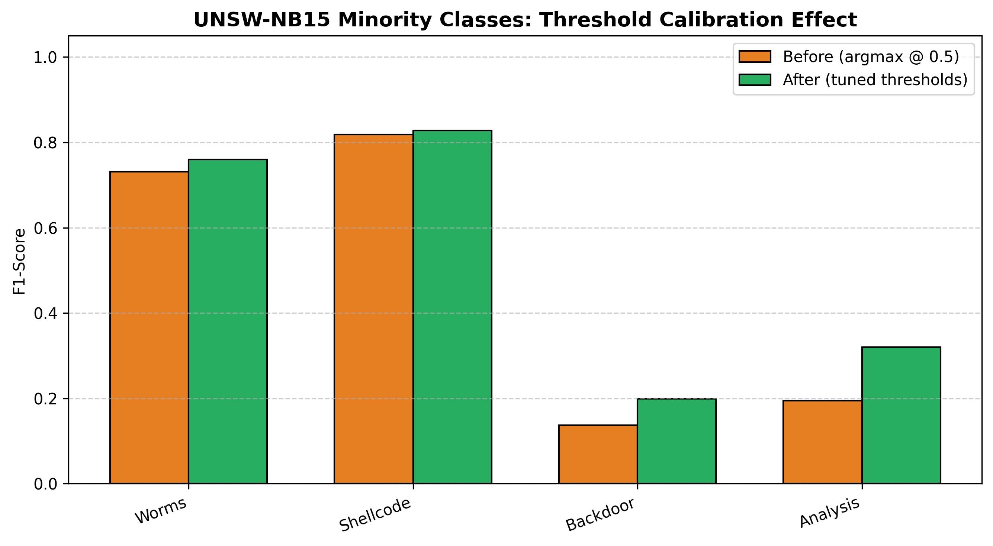
Figure U7. Minority-class F1 before/after threshold calibration (UNSW-NB15).

4.8. Positioning Relative to Published Results
Reported accuracies on CICIDS-2017 commonly exceed 99%, so a leaderboard comparison of headline accuracy would be uninformative and, given the heterogeneity of preprocessing across studies, potentially misleading. The practical challenges of meaningful comparison across NIDS systems have been systematically documented [4]. Published pipelines differ in sampling fraction, train/test protocol, the set of retained classes, and whether resampling and feature selection are confined to training data; several widely cited results apply SMOTE before cross-validation, which inflates minority-class scores through test-set leakage, a recognised pitfall in security-oriented machine learning [43]. The highest reported accuracy in Table 10, 1.000 (Arreche et al. [5]), is achieved on a 7-class label set using prediction probabilities as stacking inputs; our 12-class evaluation is a substantially harder task, and macro-F1 is a more diagnostic metric than headline accuracy when class sizes differ by three orders of magnitude. We therefore do not claim a new state-of-the-art accuracy. The contribution is methodological and is designed to be robust to these confounds: a controlled demonstration that paradigm diversity, not added members, is what lets an ensemble beat its best member; a leak-controlled evaluation in which resampling and threshold calibration never touch held-out data; and an explanation-consistency result that holds on two benchmarks built by different feature extractors. For readers seeking direct comparability, all hyperparameters, the fold protocol, and the class list are disclosed in Table A so that the reported numbers can be reproduced exactly rather than compared across incommensurable protocols. The same reasoning governs comparison with the recent explainable-IDS systems of Section 2.1: their headline metrics arise from different label sets and protocols, and none reports an explanation-consistency measurement, which is the quantity this work is designed to deliver.

Table 10. Related works on CICIDS-2017. † Weighted/overall F1. ‡ Macro-F1 (all 12 classes weighted equally). [16] Fitni & Ramli (2020) uses CSE-CIC-IDS2018; [2] Al-Omari & Al-Haija (2024) uses UNSW-NB15 only; both excluded.
Ref | Study | Method | Acc | F1 | Notes
[5] | Arreche et al. 2024 | Two-level ensemble | 1.000 | 1.000† | 7-class; Level 01 prediction-probability stacking; best of XGB/LGBM/Bag_DT/Bag_LGBM (their Table 15). IEEE Access 2024.
[6] | Arreche et al. 2024 | XAI-IDS (best of 7 models) | 0.990 | 0.990† | 7-class; XAI-IDS, best of 7 black-box classifiers (ADA, top-15 features, their Table 7). Appl. Sci. 2024.
Ours | This work | Stacking (CB+ET+EBM) + thresholds | 0.9983 | 0.8982‡ | 12-class; 5-fold CV; leak-proof; wF1=0.9984; MCC=0.9951
Note: protocol differences (sampling fraction, CV approach, class set, leakage controls) prevent direct metric comparison; see the discussion opening this section.

Table 11. Positioning summary — related works on UNSW-NB15. [30] is a dataset introduction paper with no classification results. Binary-classification result ([2]) is not directly comparable to our 10-class setup.
Ref | Study | Method | Acc | F1 | Notes
[30] | Moustafa & Slay 2015 | -- | -- | -- | Dataset introduction paper (MilCIS 2015); no classification results in paper; verified from PDF
[2] | Al-Omari & Al-Haija 2024 | Hybrid FS (CA+MI+RFECV) + RF | 0.978 | 0.978 | Verified from paper PDF; binary classification; 22 features; JISIS 14:2 2024
Ours | This work | Stacking (CB+ET+EBM) + thresholds | 0.8141 | 0.5817 | 5-fold CV; leak-proof; wF1=0.8206; MCC=0.7618; 10 classes (9 attack categories plus Normal)
Note: 'F1' for binary studies collapses to standard binary F1; our macro-F1 is averaged over all 10 classes (9 attack categories plus Normal).

5. Limitations and Future Work
Cross-dataset transfer without retraining remains hard. Although both datasets were evaluated natively (Sections 4.1–4.6 on CICIDS-2017, Section 4.7 on UNSW-NB15), a model trained on one and applied to the other without retraining transfers poorly, because the two feature extractors are largely disjoint: CICIDS-2017's CICFlowMeter computes packet-length-variance and inter-arrival statistics that UNSW-NB15's toolchain does not, so transplanted models receive zero-filled inputs for their most informative features. Robust transfer in NIDS remains bottlenecked by the absence of a standardised feature extractor; the present work addresses generalisation by native retraining and by demonstrating that the architecture and its explanation-consistency property hold on both benchmarks, rather than by claiming zero-shot transfer.
Computational scope and fixed configuration. CICIDS-2017 experiments use a 20% stratified sample (565,563 flows), a disclosed design parameter; stratification preserves the full class distribution. The subsample caused the three rarest classes (Heartbleed, Infiltration, SQL Injection) to fall below the 15-sample floor and be excluded (Section 3.1), so the reported minority-class results do not cover the very rarest CICIDS-2017 attacks. Documented labelling imperfections in CICIDS-2017, which partly concern web-attack traffic [42], counsel additional caution for the absolute web-attack figures in Section 4.3. All model hyperparameters were fixed a priori (Table A) without per-dataset tuning, so the voting-versus-stacking comparison characterises the combination rule under one disclosed configuration; margins could shift under per-model hyperparameter optimisation.
Both datasets cap EBM's per-fold training at 100,000 rows, a standard scalability measure whose effect is bounded given EBM's competitive standalone accuracy. Feature-selection leakage was tested directly with a control experiment. Although the hybrid Mutual-Information-plus-Random-Forest ranking in the main pipeline is computed once on the full data, we re-ran the entire stacked-ensemble evaluation with the ranking re-derived inside each fold on training data only, on the same fold partition. On UNSW-NB15, this left performance essentially unchanged (accuracy Δ=−0.0005, macro-F1 Δ=−0.0011), with 100% of selected features shared per fold, confirming the global ranking confers no optimistic bias on that dataset. On CICIDS-2017 the result differs: in-fold FS yields accuracy 0.9970 vs 0.9983 (delta -0.001) and macro-F1 0.8625 vs 0.8982 (delta -0.036), with 85% feature overlap per fold. The accuracy gap is negligible; the macro-F1 gap reflects noisier within-fold MI estimation for the rarest attack classes, each contributing under 0.2% of per-fold training samples and producing less stable per-fold rankings than on UNSW-NB15. The reported macro-F1 of 0.8982 is therefore an overestimate; the leak-free in-fold estimate of 0.8625 is the conservative figure for minority-class performance, and the per-class web-attack results of Sections 4.2–4.3 inherit the same optimism. Residual minority weakness: on CICIDS-2017, XSS precision (0.33) reflects genuine statistical overlap with benign HTTPS traffic in flow space; on UNSW-NB15, the Analysis and Backdoor classes overlap similarly; both are boundaries of flow-based detection that only payload-aware (deep-packet-inspection) features could cross. Threshold transferability: tuned thresholds reflect each dataset's class prevalence and should be re-calibrated per deployment, which the leak-free calibration-slice procedure makes routine. Categorical encoding: UNSW-NB15's proto, service, and state fields were ordinally label-encoded for all members; one-hot or target encoding may shift their attributions. Future work: federated deployment of the glass-box-augmented stack [35]; adversarial robustness testing [3]; and extending the agreement study to per-class and per-sample (local) explanation consistency.

6. Conclusion
This work set out to make the explanations a deployed NIDS delivers to its operators checkable, and to show that the check can be built into the system itself. Embedding the glass-box EBM as a deployed base learner enabled what is, to our knowledge, the first explanation-consistency study in NIDS between exact and post-hoc attributions, with Spearman ρ = 0.775 (CICIDS-2017) and 0.840 (UNSW-NB15), both significant at p < 10⁻⁵, providing external corroboration, across two structurally different members, for the SHAP explanations delivered to analysts (Section 4.5). Top-10 feature agreement is 0.9 on CICIDS-2017 and 0.8 on UNSW-NB15; positional rank agreement transfers on CICIDS but not on UNSW, a boundary condition attributable to higher co-linearity in Argus/Zeek statistics (Section 4.7). The detection engineering underneath the framework began from a negative result: a conventional XGBoost+LightGBM+Random-Forest voting ensemble could not beat its own best member. That result was converted into an architecture: three structurally different learners (CatBoost, ExtraTrees, EBM) combined by stacked generalisation under a leak-proof, fully paired evaluation. The stacked ensemble reaches 99.83% accuracy (weighted F1 0.9984, MCC 0.9951), significantly outperforming its best base member and a strong LightGBM reference (28.1% relative error reduction), where soft voting fails both tests. Inter-arrival-time features emerged as the binding constraint on web-attack detection in the feature-count ablation (worth 4–5× in minority F1, more than any resampling strategy, though not isolated by a controlled single-group ablation), and real-prevalence threshold calibration gives operators an inspectable false-alarm dial with a statistically significant net accuracy benefit. At 4.33 µs parallel inference on CICIDS-2017 (29.8 µs on UNSW-NB15), the system meets real-time requirements on commodity hardware. Critically, the diversity-driven mechanism, the stacking advantage, the threshold-calibration benefit, and the explanation-consistency result all replicate under native retraining on UNSW-NB15, a benchmark built by a different feature-extraction toolchain, with SHAP–EBM agreement strengthening to ρ = 0.840, providing evidence that the contributions are not specific to a single feature-extraction toolchain. The CICIDS-2017 macro-F1 of 0.8982 reflects the global feature-ranking pipeline used throughout; in-fold feature ranking, tested as a leakage-control experiment in Section 5, yields a conservative estimate of 0.8625, with 85% feature overlap per fold and no effect on any comparative conclusion or the stacking advantage. Together, these results argue that trustworthy network intrusion detection is achieved not by attaching explanations to an accurate black box, but by building ensembles whose accuracy and explanation consistency are evaluated within the same architecture.

Declarations
CRediT author statement: Khandaker Saifuzzaman: Conceptualization, Methodology, Software, Validation, Formal analysis, Investigation, Data Curation, Writing – original draft, Writing – review and editing, Visualization.
Competing interests: The author declares no known competing financial interests or personal relationships that could have influenced this work.
Funding: This research received no external funding.
Data availability: CICIDS-2017 is publicly available from the Canadian Institute for Cybersecurity at https://www.unb.ca/cic/datasets/ids-2017.html. UNSW-NB15 is publicly available from the University of New South Wales at https://research.unsw.edu.au/projects/unsw-nb15-dataset. No new datasets were created in this study.
Code availability: The complete source code, trained models, experimental pipeline, evaluation scripts, and figure-generation notebooks used in this study are publicly available in the GlassBox-Stacked-NIDS repository at https://github.com/saif4224/glassbox-stacked-nids.
Declaration of Generative AI and AI-assisted technologies in the writing process: The author used a variety of AI-assisted tools in the course of preparing this work, including ChatGPT (OpenAI), Gemini (Google), and Claude (Anthropic), to improve the language, readability, grammar, clarity, and presentation of the manuscript. These tools were used solely for manuscript preparation and did not play a role in the research design, data analysis, interpretation of results, or scientific conclusions. The author employed these tools and subsequently reviewed, verified, and edited all content as needed and assumes sole responsibility for the accuracy, originality, and integrity of the published work.

References
[1] Ahmad, Z., Shahid Khan, A., Wai Shiang, C., 2021. Network intrusion detection system: A systematic study of machine learning and deep learning approaches. Transactions on Emerging Telecommunications Technologies, 32(1), e4150. https://doi.org/10.1002/ett.4150
[2] Al-Omari, M., Al-Haija, Q. A., 2024. Towards robust IDSs: An integrated approach of hybrid feature selection and machine learning. Journal of Internet Services and Information Security, 14(2). https://doi.org/10.58346/JISIS.2024.I2.004
[3] Apruzzese, G., Laskov, P., Montes de Oca, E., 2023. The role of machine learning in cybersecurity. Digital Threats: Research and Practice, 4(1), 1–38. https://doi.org/10.1145/3545574
[4] Apruzzese, G., Laskov, P., Schneider, J., 2023. SoK: Pragmatic assessment of machine learning for network intrusion detection. 2023 IEEE 8th European Symposium on Security and Privacy (EuroS&P), 1–21. https://doi.org/10.1109/eurosp57164.2023.00042
[5] Arreche, O., Bibers, I., Abdallah, M., 2024. A two-level ensemble learning framework for enhancing network intrusion detection systems. IEEE Access, 12, 83830–83857. https://doi.org/10.1109/ACCESS.2024.3407029
[6] Arreche, O., Guntur, T., Abdallah, M., 2024. XAI-IDS: Toward proposing an explainable artificial intelligence framework for enhancing network intrusion detection systems. Applied Sciences, 14(10), 4170. https://doi.org/10.3390/app14104170
[7] Battiti, R., 1994. Using mutual information for selecting features in supervised neural net learning. IEEE Transactions on Neural Networks, 5(4), 537–550. https://doi.org/10.1109/72.298224
[8] Breiman, L., 2001. Random forests. Machine Learning, 45(1), 5–32. https://doi.org/10.1023/A:1010933404324
[9] Buda, M., Maki, A., Mazurowski, M. A., 2018. A systematic study of the class imbalance problem in convolutional neural networks. Neural Networks, 106, 249–259. https://doi.org/10.1016/j.neunet.2018.07.011
[10] Chawla, N. V., Bowyer, K. W., Hall, L. O., Kegelmeyer, W. P., 2002. SMOTE: Synthetic minority over-sampling technique. Journal of Artificial Intelligence Research, 16, 321–357. https://doi.org/10.1613/jair.953
[11] Chen, T., Guestrin, C., 2016. XGBoost: A scalable tree boosting system. Proceedings of the 22nd ACM SIGKDD International Conference on Knowledge Discovery and Data Mining, 785–794. https://doi.org/10.1145/2939672.2939785
[12] Demsar, J., 2006. Statistical comparisons of classifiers over multiple data sets. Journal of Machine Learning Research, 7, 1–30. https://jmlr.org/papers/v7/demsar06a.html
[13] Dietterich, T. G., 1998. Approximate statistical tests for comparing supervised classification learning algorithms. Neural Computation, 10(7), 1895–1923. https://doi.org/10.1162/089976698300017197
[14] Draper-Gil, G., Lashkari, A. H., Mamun, M. S. I., Ghorbani, A. A., 2016. Characterization of encrypted and VPN traffic using time-related features. Proceedings of the 2nd International Conference on Information Systems Security and Privacy (ICISSP), 407–414. https://doi.org/10.5220/0005740704070414
[15] Elkan, C., 2001. The foundations of cost-sensitive learning. Proceedings of the 17th International Joint Conference on Artificial Intelligence (IJCAI), 973–978.
[16] Fitni, Q. R. S., Ramli, K., 2020. Implementation of ensemble learning and feature selection for performance improvements in anomaly-based intrusion detection systems. 2020 IEEE International Conference on Industry 4.0, Artificial Intelligence, and Communications Technology (IAICT), 118–124. https://doi.org/10.1109/IAICT50021.2020.9172014
[17] Friedman, J. H., 2001. Greedy function approximation: A gradient boosting machine. The Annals of Statistics, 29(5), 1189–1232. https://doi.org/10.1214/aos/1013203451
[18] Geurts, P., Ernst, D., Wehenkel, L., 2006. Extremely randomized trees. Machine Learning, 63(1), 3–42. https://doi.org/10.1007/s10994-006-6226-1
[19] Guo, C., Pleiss, G., Sun, Y., Weinberger, K. Q., 2017. On calibration of modern neural networks. Proceedings of the 34th International Conference on Machine Learning (ICML), PMLR 70, 1321–1330. https://proceedings.mlr.press/v70/guo17a.html
[20] Hartl, A., Fabini, J., Zseby, T., 2020. Explainability of machine learning models for network intrusion detection. 2020 IFIP Networking Conference, 1–9.
[21] He, H., Bai, Y., Garcia, E. A., Li, S., 2008. ADASYN: Adaptive synthetic sampling approach for imbalanced learning. 2008 IEEE International Joint Conference on Neural Networks (IJCNN), 1322–1328. https://doi.org/10.1109/IJCNN.2008.4633969
[22] He, H., Garcia, E. A., 2009. Learning from imbalanced data. IEEE Transactions on Knowledge and Data Engineering, 21(9), 1263–1284. https://doi.org/10.1109/TKDE.2008.239
[23] Ke, G., Meng, Q., Finley, T., Wang, T., Chen, W., Ma, W., Ye, Q., Liu, T.-Y., 2017. LightGBM: A highly efficient gradient boosting decision tree. Advances in Neural Information Processing Systems, 30, 3149–3157.
[24] Krishna, S., Han, T., Gu, A., Pombra, J., Jabbari, S., Wu, Z. S., Lakkaraju, H., 2022. The disagreement problem in explainable machine learning: A practitioner’s perspective. arXiv:2202.01602. https://doi.org/10.48550/arXiv.2202.01602
[25] Lemaître, G., Nogueira, F., Aridas, C. K., 2017. Imbalanced-learn: A Python toolbox to tackle the curse of imbalanced datasets in machine learning. Journal of Machine Learning Research, 18(17), 1–5.
[26] Lou, Y., Caruana, R., Gehrke, J., Hooker, G., 2013. Accurate intelligible models with pairwise interactions. Proceedings of the 19th ACM SIGKDD International Conference on Knowledge Discovery and Data Mining, 623–631. https://doi.org/10.1145/2487575.2487579
[27] Lundberg, S. M., Lee, S.-I., 2017. A unified approach to interpreting model predictions. Advances in Neural Information Processing Systems, 30, 4765–4774.
[28] Lundberg, S. M., Erion, G., Chen, H., DeGrave, A., Prutkin, J. M., Nair, B., Katz, R., Himmelfarb, J., Bansal, N., Lee, S.-I., 2020. From local explanations to global understanding with explainable AI for trees. Nature Machine Intelligence, 2, 56–67. https://doi.org/10.1038/s42256-019-0138-9
[29] Mirsky, Y., Doitshman, T., Elovici, Y., Shabtai, A., 2018. Kitsune: An ensemble of autoencoders for online network intrusion detection. Proceedings of the 2018 Network and Distributed System Security Symposium (NDSS). https://doi.org/10.14722/ndss.2018.23204
[30] Moustafa, N., Slay, J., 2015. UNSW-NB15: A comprehensive data set for network intrusion detection systems (UNSW-NB15 network data set). 2015 Military Communications and Information Systems Conference (MilCIS), 1–6. https://doi.org/10.1109/MilCIS.2015.7348942
[31] Neto, E. C. P., Dadkhah, S., Ferreira, R., Zohourian, A., Lu, R., Ghorbani, A. A., 2023. CICIoT2023: A real-time dataset and benchmark for large-scale attacks in IoT environment. Sensors, 23(13), 5941. https://doi.org/10.3390/s23135941
[32] Nori, H., Jenkins, S., Koch, P., Caruana, R., 2019. InterpretML: A unified framework for machine learning interpretability. arXiv:1909.09223. https://doi.org/10.48550/arXiv.1909.09223
[33] Pedregosa, F., Varoquaux, G., Gramfort, A., Michel, V., Thirion, B., Grisel, O., Blondel, M., Prettenhofer, P., Weiss, R., Dubourg, V., Vanderplas, J., Passos, A., Cournapeau, D., Brucher, M., Perrot, M., Duchesnay, É, 2011. Scikit-learn: Machine learning in Python. Journal of Machine Learning Research, 12, 2825–2830.
[34] Prokhorenkova, L., Gusev, G., Vorobev, A., Dorogush, A. V., Gulin, A., 2018. CatBoost: Unbiased boosting with categorical features. Advances in Neural Information Processing Systems, 31, 6639–6649.
[35] Rey, V., Sánchez Sánchez, P. M., Huertas Celdrán, A., Bovet, G., 2022. Federated learning for malware detection in IoT devices. Computer Networks, 204, 108693. https://doi.org/10.1016/j.comnet.2021.108693
[36] Ribeiro, M. T., Singh, S., Guestrin, C., 2016. “Why should I trust you?”: Explaining the predictions of any classifier. Proceedings of the 22nd ACM SIGKDD International Conference on Knowledge Discovery and Data Mining, 1135–1144. https://doi.org/10.1145/2939672.2939778
[37] Rudin, C., 2019. Stop explaining black box machine learning models for high stakes decisions and use interpretable models instead. Nature Machine Intelligence, 1(5), 206–215. https://doi.org/10.1038/s42256-019-0048-x
[38] Sharafaldin, I., Lashkari, A. H., Ghorbani, A. A., 2018. Toward generating a new intrusion detection dataset and intrusion traffic characterization. Proceedings of the 4th International Conference on Information Systems Security and Privacy (ICISSP), 108–116. https://doi.org/10.5220/0006639801080116
[39] Wazid, M., Singh, J., Das, A. K., Rodrigues, J. J. P. C., 2024. An ensemble-based machine learning-envisioned intrusion detection in Industry 5.0-driven healthcare applications. IEEE Transactions on Consumer Electronics, 70(1), 1903–1912. https://doi.org/10.1109/TCE.2023.3325209
[40] Wolpert, D. H., 1992. Stacked generalization. Neural Networks, 5(2), 241–259. https://doi.org/10.1016/S0893-6080(05)80023-1
[41] Yin, C., Zhu, Y., Fei, J., He, X., 2017. A deep learning approach for intrusion detection using recurrent neural networks. IEEE Access, 5, 21954–21961. https://doi.org/10.1109/ACCESS.2017.2762418
[42] Engelen, G., Rimmer, V., Joosen, W., 2021. Troubleshooting an intrusion detection dataset: The CICIDS2017 case study. 2021 IEEE Security and Privacy Workshops (SPW), 7–12. https://doi.org/10.1109/SPW53761.2021.00009
[43] Arp, D., Quiring, E., Pendlebury, F., Warnecke, A., Pierazzi, F., Wressnegger, C., Cavallaro, L., Rieck, K., 2022. Dos and don’ts of machine learning in computer security. Proceedings of the 31st USENIX Security Symposium, 3971–3988. https://www.usenix.org/conference/usenixsecurity22/presentation/arp
[44] Kuncheva, L. I., Whitaker, C. J., 2003. Measures of diversity in classifier ensembles and their relationship with the ensemble accuracy. Machine Learning, 51(2), 181–207. https://doi.org/10.1023/A:1022859003006
[45] Dietterich, T. G., 2000. Ensemble methods in machine learning. Multiple Classifier Systems, Lecture Notes in Computer Science, 1857, 1–15. https://doi.org/10.1007/3-540-45014-9_1
[46] Lou, Y., Caruana, R., Gehrke, J., 2012. Intelligible models for classification and regression. Proceedings of the 18th ACM SIGKDD International Conference on Knowledge Discovery and Data Mining, 150–158. https://doi.org/10.1145/2339530.2339556
[47] Caruana, R., Lou, Y., Gehrke, J., Koch, P., Sturm, M., Elhadad, N., 2015. Intelligible models for healthcare: Predicting pneumonia risk and hospital 30-day readmission. Proceedings of the 21st ACM SIGKDD International Conference on Knowledge Discovery and Data Mining, 1721–1730. https://doi.org/10.1145/2783258.2788613
[48] Niculescu-Mizil, A., Caruana, R., 2005. Predicting good probabilities with supervised learning. Proceedings of the 22nd International Conference on Machine Learning, 625–632. https://doi.org/10.1145/1102351.1102430
[49] D’hooge, L., Wauters, T., Volckaert, B., De Turck, F., 2020. Inter-dataset generalization strength of supervised machine learning methods for intrusion detection. Journal of Information Security and Applications, 54, 102564. https://doi.org/10.1016/j.jisa.2020.102564
[50] Wang, M., Zheng, K., Yang, Y., Wang, X., 2020. An explainable machine learning framework for intrusion detection systems. IEEE Access, 8, 73127–73141. https://doi.org/10.1109/ACCESS.2020.2988359
[51] Warnecke, A., Arp, D., Wressnegger, C., Rieck, K., 2020. Evaluating explanation methods for deep learning in security. 2020 IEEE European Symposium on Security and Privacy (EuroS&P), 158–174. https://doi.org/10.1109/EuroSP48549.2020.00018
[52] Neupane, S., Ables, J., Anderson, W., Mittal, S., Rahimi, S., Banicescu, I., Seale, M., 2022. Explainable intrusion detection systems (X-IDS): A survey of current methods, challenges, and opportunities. IEEE Access, 10, 112392–112415. https://doi.org/10.1109/ACCESS.2022.3216617
[53] Arreche, O., Guntur, T. R., Roberts, J. W., Abdallah, M., 2024. E-XAI: Evaluating black-box explainable AI frameworks for network intrusion detection. IEEE Access, 12, 23954–23988. https://doi.org/10.1109/ACCESS.2024.3365140
[54] Wali, S., Farrukh, Y. A., Khan, I., 2025. Explainable AI and Random Forest based reliable intrusion detection system. Computers & Security, 157, 104542. https://doi.org/10.1016/j.cose.2025.104542
[55] AL-Nomasy, N., Alamri, A., Aljuhani, A., Kumar, P., 2025. Transformer-based knowledge distillation for explainable intrusion detection system. Computers & Security, 154, 104417. https://doi.org/10.1016/j.cose.2025.104417
[56] Gao, Y., Yang, L., Zhu, R., Wu, Y., Yang, F., Cao, Y., 2025. IR-IDS: A network intrusion detection method based on causal feature selection and explainable model optimization. Computers & Security, 155, 104496. https://doi.org/10.1016/j.cose.2025.104496
[57] Cerasuolo, F., Bovenzi, G., Ciuonzo, D., Pescapè, A., 2025. Adaptable, incremental, and explainable network intrusion detection systems for internet of things. Engineering Applications of Artificial Intelligence, 144, 110143. https://doi.org/10.1016/j.engappai.2025.110143
[58] Mohale, V. Z., Obagbuwa, I. C., 2025. A systematic review on the integration of explainable artificial intelligence in intrusion detection systems to enhancing transparency and interpretability in cybersecurity. Frontiers in Artificial Intelligence, 8, 1526221. https://doi.org/10.3389/frai.2025.1526221

